**1959**

…“it has been a busy time.” Dad passes his German test on the first try! Mom sews. Dad breaks the Sabbath and confesses his sin. Mom sews. Dad gets madder than he has ever been at anyone in his life. Mom sews. She also teaches, plays piano, runs a home, and grows a baby in her belly. Lesle learns to say *magic*, and to shout *No, No!* She is awed. She escapes. She gets into everything. And sometimes she is *real good*. Lisa is born, and Dad finds just the right words to express his joy: “She is so much fatter in the face than Lesle was.”

**1-14-59 – Wed 6:00 PM -** Dear Mother, Glad to have your letter today. Lesle and I are over most of our colds but Ruth had an ear infection the last week and had a shot of penicillin every day since last Wed up till yesterday. She taught school that Mon and Tues and then had to stop. Congratulations to Bill. The pictures of Lesle and Jimmy are good. Tell Aunt Clara hello and goodbye. The exam is Sat from 9-11 AM took the book over last Mon morning. We missed choir last night but Ruth goes to circle tonight. I sang last Sun but Ruth didn’t. Ruth is new treasurer (I guess I told you) of s.s. class. Have studied German all week.

**1-19-59 – Mon 6:30 PM -** I’m writing this in bed as I’ve been down all day. I felt fine yesterday – relaxed and etc. after the exam. I took sick shortly after and went to bed and vomited and had diarrhea. I guess that’s the first time I’ve vomited since that time we were both sick after having been up at Bill Gardner’s. Lesle vomited this morning but has seemed OK since except that she is more tired than usual.

Lesle had her first bath in the big tub tonight and was somewhat awed at first. She loves to splash and make a big mess. Up till today Ruth had been giving her her bath in the kitchen sink but that was getting too small with all her splashing etc.

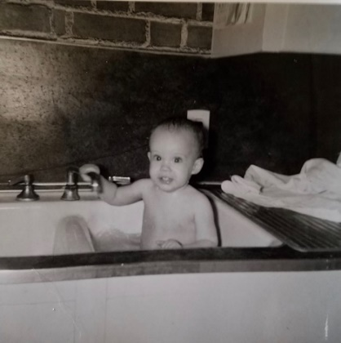 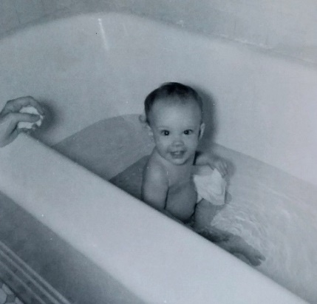

Lesle walks fairly well now although she takes an occasional tumble which makes her quite unhappy. She says “hi” “dada” “mama” “baby” and “pretty”. Yesterday I put up two gates for her, one to the basement and one to her bedroom. We were glad to receive your letter today. Ruth says thanks for her birthday present and for Lesle’s spoon. It is so much easier to feed her with that spoon. She’s eating some with her fingers and really makes a mess. She still likes crackers and rice cheks better than solids that we eat. Sometimes she wants to hold the spoon herself.

I’m missing a lecture tonight. Tonight is the regular night for our graduate course but it was called off on account of the lecture (a visiting biochemist). Ruth had a final appointment for her ear today but had it postponed till tomorrow because I was sick and Lesle didn’t feel too well either. We’ll probably go to choir practice Thurs night if we’re all well. We haven’t been to choir practice for several weeks. ?!

You have a standing invitation, now that Aunt Clara’s gone, to come here for any weekend. From your letters it sounds as if you have Grandmother underlined from here to the end of the sentence about as many activities as you ever had, but I know you still get lonesome. If you come don’t worry about the time that I might have to go meet you and feel free to come on Fri night if you want too. Ruth’s dad called her last night to wish her happy birthday. Her mother leaves today to drive to Austin, Tex to visit Eldon. She just had a small-pox vaccination as she may go on to Mexico with a cousin from Odessa, Texas.

I hope Bill likes his new position fine. I suppose he will since thats what he wanted to do ultimately. I know he’ll have to study some as I guess they expect the farm agent to be “up” on all the new insecticides and things like that. Ruth had a birthday note from her grandmother today and also a card from Marianne (her roommate from Sweden). Her dad had given me $5 to put on a new toaster. I gave her a choice of a toaster or a waffle iron but she hasn’t decided on which one she wants yet. We have to get new tags for the car right away.

Yesterday morning we all went to s.s. and church. Our new teacher is fine and they want me to stay on as song leader. So many times we’re just a few minutes late so I told them to also have a substitute song leader readily. Ruth didn’t sing in the choir again. Dr. Bob Moser (a class member) gave us their stroller for which they will have no more use. We stopped at the store and got that on the way home from church. Since the day was warm and the car so dirty I gave it a once over. There have been many little jobs that I put off because of the exam. My hands got cold washing the car but I don’t think it probably made any difference for my taking sick. I burned the trash and in the evening, sorted through the 2 boxes of small magic things and got them in order.

Its now Tues morning and there’s almost 2 inches of snow on the ground. I had thought I’d go to the building some today but with the snow I’d have to put chains on so guess I won’t try it today. I’ll have to put them on tomorrow when I go down. I guess Ruth will have to take a cab if she goes this afternoon. The weather report calls for at least 5 inches of snow and very slick streets. Lesle had a bad night as she vomited at 1:00 and 3:00 AM but I guess she has no fever. Ruth is tired out from getting up with her and changing bed etc. I feel much better today and will eat more, also. Ruth gave me a haircut Sun night before she went across to watch some TV.

We bought several extra records with the Christmas money and have been enjoying them very much – Brahms, Beethovin, Bach etc. Sat morning I just made it in time for the exam at 9:00 AM. I was tense at first but calmed down later, however, I just don’t see how I could have passed. I couldn’t think too fast and there were some words that I just didn’t know at all. I haven’t felt badly about it because I feel that even if I didn’t pass that I gave it my very best. The exam was over at 11 (about 20 took it) and then Ruth and Lesle met me after having visited Dr. John Patton’s father. We then went by and I introduced Ruth and Lesle to Dr. Wenzel. We visited awhile and then all went back to Mary and Gary’s for lunch. Gary had exams in the afternoon and I watched KU and Oklahoma play basketball on TV and babysat (for 2) while Ruth and Mary did some shopping. We listened over the radio to that emergency landing of the big airliner which you probably read about. We left about about 5:00 and ate at a drive-in after we arrived in K.C. We spent the evening at home relaxing. Ruth watched TV awhile. I guess it’s better you didn’t get TV this year as the big shows are all westerns, mysteries and detective stories.

We went to Lawrence last Mon (a wk ago yesterday) morning so I could turn my book. We all got to visit Miss Grant (Ruth’s former Greek teacher whom she likes very much and whom had never seen Lesle – I had never met her either). I checked at the graduate office and found that I had made A’s both quarters last year in microbiology – I knew I had the first qt but not the second. I also visited Dr. Wenzel, Dean Reece (School of Pharmacy) and Miss Chapman (Sec of the Sch of Ph). Ruth visited some people and found out that Lesle is the first baby born to a former holder of a Watkins Scholarship at KU. (That’s the women’s scholarship equivalent to a Summerfield you know.)

Last week was a hard week with Ruth and sickness and trying to study etc., but I don’t feel that the time I lost made any overall difference on the German. For the next 6 wks I will start studying some for prelims and also study for the graduate course (exam and seminar) and start some new lab work. If I passed German my prelims will be in April, if I didn’t I’ll hire a tutor starting about the 1st of March and take about 10 lessons up until the next German exam on May 9th. If I pass then, then the prelims would be the latter part of May. After prelims you have to have 1 full academic year or 9 months. Hope you’re OK and tell M.J., Bill, Uncle Clyde and Aunt Clara hello.

**1-25-59** – Mom writes to Aunt Clara - No doubt you’re glad you’re in Texas after the weather we’ve been having lately. We had about 8” of snow, but it’s mostly melted now. Carroll’s mother probably already let you know that he passed the German exam. Yay Dad! The first thing he told me when he came out was that he’d be taking it again in May. He was overly pessimistic, wouldn’t you say?

We’ve stayed pretty close to home since Christmas because of colds, intestinal flu, and my ear infection (I’m still getting a shot a day of penicillin). We’ve decided we’re all going to live, though, so we’re beginning to come out of retirement now. You probably know I did some substitute teaching right after Christmas. I’ve been asked several times since, but refused because of my ear. It’s kind of fun for a day or two, but I don’t like to leave Lesle any more than that. There’s a nurse across the street from the medical center who takes care of Lesle when I do teach.

Carroll is still songleader at Sunday School. The new class president wanted him to stay on. Of course, we’re singing in choir, too. Lesle wants to walk all the time now. If we try to hold her hand she indignantly pulls it away. She’s beginning to learn “no, no” and is very outraged by it. So far she doesn’t like her trainer chair unless she’s fully clothed, but I think she’ll get over that if we’re just patient and take it easy. You’ll have to come see the way our house looks now. Lesle’s room and the dining room are rearranged. Write when you have time.

**? – 2:00 PM – Wed afternoon –** Sorry I haven’t written you sooner. Today is somewhat warmer but cloudy and somewhat foggy (sp?). Mon afternoon Ruth came for her final ear check, and although there was still some fluid he said not to come back if the eardrops he gave her helped it to drain. She thinks it has has so probably won’t have to go back.

Mon afternoon it started snowing and snowed about 2 inches. I had to put my chains on to get safely back down the hill. That is the 3rd time this winter I’ve had to put on chains to make it up and down the hill. I would have had to put them on at Thanksgiving if we had been here. I came back Mon night to the graduate course. It only runs one more month and then I’ll be free on Mon nights. I must get started studying for the course exam and also for my seminar at the last session. My preliminary exams are scheduled for around May 18-20th. These consist of oral and written exams in both major and minor subjects i.e. pharmacology and physiology, and may be spread over a period of several days. I should finish around the first of March 1960, and should have plenty of time to complete my research problem by that time. Since the work I did from last July 1st till I stopped early in Dec to study for German, was negative we are switching my problem to one that I worked on last winter and spring.

Tues (last night) we stayed home as we will tonight. We’ll probably go to choir tomorrow night. I have had more cold and hoarseness the last week and can’t sing too well. (Maybe I should have the penicillin as my ears fill up sometimes). This coming Sat night we may go to a show to celebrate. Thanks for the gift. Tell Aunt Clara we may use part of it to have the piano tuned. Ruth says it needs it badly as it has not been tuned since she gave it to us. We had a nice letter from Aunt Clara, also. Any weekend in Feb will be fine for us as we have nothing special planned. Last week we went to choir on Thurs night and hired a babysitter. Lesle walks everywhere and only very seldom falls. However, she still can’t pull herself up completely from a sitting position.

Fri afternoon after Ruths apointment we left Lesle with Mrs. Brownfield and went downtown and got our license plates $11. We stopped downtown and bought a few plants for the planter I gave Ruth at Christmas. We also bought one for Mrs. Brownfield. Since she has been so good about keeping Lesle occasionaly and in emergencies. Ruth may buy her a jumper ($5 outfit) that she wants so much. Mrs. Brownfield is a good Catholic although her husband is not a member. Ruth enjoyed her 2 days teaching and had 2 more calls but had to turn them down on account of her ear. We still have a little snow.

Sat morning I worked in the library and in the afternoon we cleaned the house and got ready for company. Our company for dinner was Dr. and Mrs. Charley Wilson. They are Presbyterians and their name was given to us to call on, invite to church etc. She has been to s.s. a few times and has gone to circle with Ruth, but he has never been to church. He had polio, walks with a limp and they are both very nice. He’s about my age and is an intern here, while she works as a secretary here. We listened to some records and they left about 9:30.

Sun morning we all went to church. Ruth had to stop by here for a shot on the way. I was on time to lead the singing but couldn’t do very well because of my hoarseness. Had a big crowd as it was coffee morning (we were too late). We both sang in choir. I was the only bass besides the soloist but didn’t contribute too much. We stopped by the grocery and drug stores on the way home. I read, studied and rested the rest of the day. I guess that’s about all we’ve done of importance. Tell Aunt Clara, Uncle Clyde, M.J. and Bill hello. You can send this on to Aunt Clara if you want too. P.S. I should get more than $300 back on income tax.

**2-4-59 – Wed 10:45 PM -** We were glad to have your letter today and all the clippings. Today has been warmer and I took the tire chains off this morning after having them on since Sun morning. The roads were pretty clear by yesterday. The same snowstorm which you described in your letter hit here last Sat night and there were (Looks like Dad had written ‘was’ and Mom crossed it out and wrote ‘were’ above it ☺) 3 inches by morning. Our big snow had just finished melting when it came.

Tomorrow night is choir and I imagine we’ll go as usual. I must study hard this weekend for the graduate course. I’ve been doing some reviewing for prelims. Mon night was the course lectures and then there was another guest lecturer last night that I went to hear. Last Sun morning Lesle had another touch of cold so I went and Ruth and Lesle stayed home. It was snowy and cold anyway, so probably better they stayed in. There were 20 in s.s. and I took care of the money for Ruth. A smaller crowd in church and again I was the only bass besides the soloist. I could sing all right by Sun as my throat was well. When my throat (hoarseness etc.) didn’t get better last week I took a series of tablets of an antibiotic that I had saved for such a purpose, and it seemed to clear it up. Ruth’s ear is OK, I guess, although she said it hurt a little today. We stayed home all the rest of Sun.

Last Sat morning I worked in lab awhile and we stayed home in the afternoon. We went out for dinner and then to a show in the evening. It was starting to snow as we left and was getting slick as we started home. We just barely made it up the hill without chains – it would have been a nuisance to have had to put them on somewhere along the street. Our Ford is so much lighter than other cars in the rear that it gives very little traction without snow-tires or chains. We went to choir practice last Thurs night (had sitter) and stayed home Fri evening.

Grandmother made ink marks in the margins on both sides of the following 3 sentences. Ruth has had to do a lot of resting (Dr.’s orders) recently because it looks as if you will become a grandmother for the 3rd time about the 21st of September. This one has been planned for and Ruth says she thinks it’s best to have the 1st two children close together and then to wait till they begin school before having any more. After the weather gets warmer and Ruth has more energy we may buy that dryer as you can see we’ll be needing it this fall. We had planned to have another couple up for dinner (from s.s. class – we had another couple up recently you know) but their baby is due anytime and since Ruth is tired we’ll have to put it off. It doesn’t seem possible that Lesle will be a year old before long. We want to get her a “grow-up” crib before long. The Holladay’s new baby Kevin is a month old so we’ll have to return the playpen before long.

Ruth and two other neighbor ladies are having a piano tuner on the 19th. We have put it off longer than we should have. Feel free to come some weekend if you want too, even with Ruth not up to par. (The house might not be perfect when you arrive.) Ruth’s Mother is in Texas but we haven’t heard from her. Mr. Laidig sent Ruth a new dress by mail, via Spiegels. Well its 11:15 and almost bed time. Tell Aunt Clara, Uncle Clyde, M.J. and Bill hello. That column of Bill’s is nice. My commencent would be June 1960 but should be able to finish before that.

**2-12-59 – Thurs 4:30 PM –** As usual I’m late on getting this written but I usually like to wait for your letter so I can answer any questions. Dr. Walaszek is gone to Michigan today and tomorrow so we three graduate students have the two labs to ourselves. We learn a lot by talking over problems together, etc. Tonight is choir practice and we have the babysitter coming again. We told her to figure on every Thurs night till the weather is warmer. Lesle is now free of cold but Ruth is hoarse again – we just can’t seem to all get free of colds at the same time. Hugh Burford’s wife (graduate student), who is a nurse, stayed home today with a cold, also.

We had a bad ice storm here last Mon also, although the main thoroughfairs were clear most of the times and I didn’t have any trouble on the hill. As soon as the streets get slick they sprinkle sand, etc., so its usually not too bad. However, I’m awfully tired of winter and am ready for warm weather. We went to choir last Thurs night and were home Fri night, I believe. Sat morning Hugh and I helped Dr. Lum set up equipment for the student lab (sophomores) which starts in March. In the afternoon we went to downtown Kans City, Ks and Ruth bought some material, light brown and brown with white spots to make a new outfit which she will need before too long.

Ruth has sorted and clipped all of our old magazines and has given them to Mrs. Brownfield for her girl scouts. Sat we also put in a reservation on a new bed for Lesle which we will call for around her birthday. The week-end of Mar 6th or the one later will be fine with us. If you come the 6th we’ll try to have the bed so you can see it. Lesle received a valentine today from her great Uncle Earl and a new dress from some former KU students (Ruth’s friends). They had never sent a gift when she was born. Back to Sat – we ate out that evening and left Lesle with Mrs. Brownfield.

Sun morning we all went to church but I was too late to lead the 1st song. Had a good crowd and the officers were installed, Ruth is treasurer, you know. This morning Ruth accepted the job of devotions chairman for her circle. Yesterday she played the piano twice, morning and afternoon, for the church school at the Shawnee Rd Christian Church down in the next block. She may get a 3rd piano pupil from the family that lives in the new house, across the corner to the North. Tues they called and Ruth substituted for the 2nd grade teacher at Major Hudson School down a ways on Shawnee Rd.

We sang in choir last Sun and I was only extra bass again. Stopped by the store on way home and then read and rested in the afternoon. In the evening we went to family night at 6:00 and home about 8:30. Every year they have family night every Sun night during the month of Feb. We missed the first one. They serve sandwiches and drink and then there are talks on missions. The topic was Mexico last Sun and many of the slides (shown by a man who had taken a vacation in Mexico) reminded me of the movies that M.J. took. Mon night was the graduate course and although there was lots of ice the roads weren’t too bad and I went home for supper. I stayed home Tues and Wed nights but Ruth had a cabinet meeting last night at the home of our new teacher. The class president took her and brought her home. I put Lesle to bed.

Tell Aunt Clara, M.J. and Bill, Uncle Clyde and all hello. The 2nd and 3rd weeks in March will be best as that will be after the graduate course and its exam and seminar is over and it will be before I begin lots of heavy studying for prelims. I’m glad the news wasn’t too much of a shock. Ruth’s still quite tired but is feeling better. For a boy we had thought of Carroll as a middle name rather than a straight Jr. as I never liked to be called Carroll Jr. and its so confusing. If you come in March we’ll plan on a weekend in Hutch later in the spring or right after my prelims. Hope you feel better. That drug you’re taking is probably Butazolidin and is the same one you took one other time. It can be toxic to the blood-forming organs and that is probably why he checks your blood. Today is warmer and the snow and ice is all gone. I sent in income tax. Should get $225 back. If they took out for 3 exemptions, instead of 2, I wouldn’t get so much back.

**2-25-59 – 10:00 PM – Wed -** I’ll write this tonight so Ruth can ‘censor’ it when she gets home. She says I always write your letters while I’m at work and she doesn’t get to read them. Tonight she is gone to a s.s. class cabinet meeting. I was supposed to go but decided to stay home and work on my seminar. I also oiled the sewing machine tonight. Today has been warmer and it seems almost like spring. Ruth was quite busy today and yesterday. Yesterday she had her two new piano pupils and this morning she played piano again at the Christian Church. She was supposed to play again at 1:00 but was on the program at church – the monthly women’s meeting. They said they could understand every word she said. She had another pupil this afternoon and in the morning she sees Dr. Spanos, the obstetrician.

Tomorrow night is choir and we’ll have a babysitter as usual. Today Ruth typed up a new list of choir members and their robe numbers. She had to do this since we were elected robe chairmen for this year. I’ll have to stay home this weekend and work on the seminar. After the seminar I’ll have a week to 10 days to study for the exam and then back to studying for prelims until May. After that it’ll be somewhat easier although we’ll have two graduate courses again next year.

We’re all fairly free of colds at the present time. Ink marks in the margins next to the following sentence. Lesle is getting into everything and the babysitter at the church said she’d never seen a 1 year old walk and talk as well as Lesle. She’s learned where the light is, her shoes, and several other new things. She very seldom falls and when she does she partially catches herself. She still has trouble doing hardly any crawling.

Mrs. Laidig got here last Sun night while we were gone to the last family night at the church. She had stayed across the street until we got here. She had taken her time and driven carefully thru some of the mountains etc. We weren’t worried but had been looking for her for 2 or 3 days. Mr. L called Sun evening, also. She stayed until early Tues morning. Mon afternoon Ruth had rehersal at church for todays program and then she and her mother went to a Tupperware party at one of the neighbors. Mon night I had class, as usual. We were home last evening but Ruth watched TV awhile. Sun morning my solo went OK in s.s. I sang “How Lovely Are Thy Dwellings.” (Ruth just came in and said Rev. Moyes said I should sing a solo the night of the Easter film which is sponsored by our class.) We sang in the choir and then were home for a roast beef dinner. Ruth had to make sandwiches for the family night program on the Caribbean. It was her circle’s turn.

We were home Fri night and then Sat morning I was at the building as usual. I stayed at home in the afternoon while Ruth went shopping. She also went out Fri morning. Sat evening we had dinner with the Burfords. Hugh and I studied awhile while the women talked. Lesle went to sleep on their new baby bed (their baby is due in about 6 wks). We were glad to have your letter today. I’m behind on the clippings but will finish them up after the exam, etc. Guess thats about it. Tell Aunt Clara, Uncle Clyde, M.J. and Bill hello. I must get my state income tax off so they won’t “catch” me again.

**3-4-59 – 10:45 PM Wed –** Well, the last week has certainly gone fast since I wrote you a week ago tonight. We’re all very tired tonight after a big day. It has been raining some since this afternoon and we may get some snow. We were glad to have your letter yesterday and hope your leg gets along OK. This morning we were all up early but I was late to the building as I first took Ruth to play at the church school (at Christian Church – she was a few minutes late) and then I had to pick up Joe Underwood (graduate student who starts course work in Lawrence next year). Joe bought a used car but they had never sent the registration so he could not buy his car licence and **henceforth** ☺ did not want to drive since they’re now fining them. I’ve taken him down and brought him home each day this week.

This morning I loaded the baby basket and its base in the car and we took it by for the Hugh Burfords after work. The preachers wife kept Lesle this morning and the regular babysitter had her at the afternoon school. I came home at 12 and Ruth took me back so she could have the car this afternoon. She had a sack lunch for me so I could run my experiment without delay. Last Sat we bought ($18) an unfinished record cabinet at Wards and after we got home found it to be defective. After church school this afternoon Ruth drove clear back out to Wards (main warehouse in Missouri and 30 min drive) to exchange it. However the next 2 or 3 they brought down were also defective so she got her money back and came back to an unfinished shop near here and got a better one. Lesle stayed with Mrs. Brownfield all afternoon and Ruth came and got Joe and me after seminar (6:00). This evening I studied and Ruth started finishing the cabinet.

Ruth washed the curtains Sat and they all shrank enough that she is having to take out all the hems and it is quite a big job. Mary and Gary and Roger Corman are coming over from Lawrence for supper Sat so Ruth wants the cabinet done by then. The new bed for Lesle will be here Fri and then we’ll return the playpen to the Holidays and her baby bed will become a playpen. The cabinet that now holds the music in the hall will go into Lesle’s room. Last evening I helped around the house some and then studied awhile. Our graduate course exam is a wk from Fri and I’ll need all the time between now and then for study. Last Mon night our lectures (Hugh and I) went OK. There were only 6 people there all together. Last Sun we all went to s.s. and church and then ate at the med. center again. Lesle was good and ate a whole little container of strawberry ice cream. She was so tired tonight that Ruth put her to bed before we had our supper. She wouldn’t take a nap at the Brownfields because of the excitement and children.

The rest of last Sun I spent finishing my seminar for Mon night. Although they haven’t ask me specifically I guess I’m to sing for that Easter film program that is sponsored by our class 2 wks from tonight, I believe. I’ll sing “Art Thou the Christ.” We should be here for choir on Easter so if OK for you we’ll plan on coming to Hutch the weekend following Easter. We plan to go to Mariners in Lawrence some Fri evening this spring. Last Sat morning I went to the building and then we drove to Wards after lunch. I stayed home the rest of the day but Ruth went out to the grocery and did some more shopping in the afternoon. We went to choir last Thurs evening (had sitter) and stayed home Fri evening. Its now Thurs morning and Ruth just got a call to teach at least this morning and maybe this afternoon, so I must put this. I’ll take her and then get Joe. Hope all are OK and tell Aunt Clara, M.J. and Bill hello.

**3-5-59 – Wed 12:30 PM –** I’ll start this now as I finish my lunch. I’ve started bringing my lunch again so I’ll have more time at noon for study, etc. Today is colder, although we did not get any of the predicted light precipitation. I just called Ruth, as I usually do at noon, and she said a card from her Mother said she would stay in Florida through today. **Henceforth**, she should be through her about Friday. We thought she was leaving Mon and would be here today. Mr. Laidig tried to call us several times Sun night while we were at church and finally got us at 8:30 after we had arrived back home. He was just lonesome to talk to Ruth, I guess, since Mrs. L has been gone so long this time.

Tomorrow night is choir practice, as usual, and I must get a lot done on my seminar this weekend. Last night I studied while Ruth went to circle. She didn’t feel too well but always enjoys getting out in the evening. The circle meeting will be at our house the 3rd Tues night in March. Mon night was class. We have 2 more including the 2 student seminars. Last Sun morning we all made it to s.s. on time, for a change. Had a big choir and two sopranos had to sit on the back row with the bases. We had 3 basses. After church we all ate at the Med Center cafeteria – Lesle was real good. She sat in a small chair on a big chair and Ruth tied her in with a diaper. We all rested in the afternoon. Wilber Murray called and said he was here visiting Lee. He said Earl Bellwood had had a heart attack and he wasn’t sure about his working this summer. I told him I couldn’t promise anything now. Sun evening we went to family night again and heard about mission work in Alaska. Lesle stayed with the babysitter. Yesterday Ruth came here for a final check on her ear. The Dr. said it looked OK and that the slight filling up she’d had was due to her cold, which she is now about over. I did not mean Carroll Jr. as the real name for a boy, but that if it was Carroll M. Smith III that would mean having to call him Carroll Jr. to distinguish him from me and I always thought it sissy to be called Carroll Jr. We had thought about Carroll as a middle name. You would only use Carroll M. Smith III if all 3 were living anyway, wouldn’t you.

Sorry you don’t think you will come now as I can assure you it would not be too much of a burden. Some weekend the last of March or during 1st part of April would be best for us to go to Hutch. Last Sat morning came to lab as usual and we stayed home the rest of the day. I studied some, etc. Ruth has done a lot of sewing and is finishing up similar outfits (shirts) for the 3 of us. Next Sun morning in s.s. I have to sing a solo for the devotional. Thanks for the valentine. I guess that’s about all for this wk. Tell Aunt Clara, M.J. and Bill, Uncle Clyde and all hello.

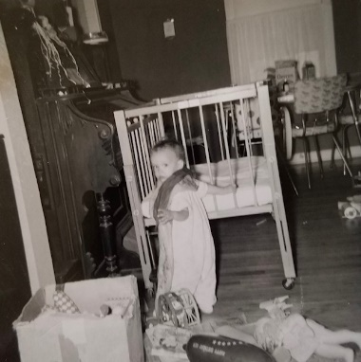

Lesle at 1 year. Mom’s organ in the background.

**3-11-59 – Wed 8:30 AM –** We were glad to have your letters and Lesle says “Thank You” for the present. She likes the new bed fine although she can’t twist the bars like she could in the old one. The old one is now her playpen and we returned the playpen to the Holladays. It is snowing this morning but I hope it won’t accumulate like it did last week on Thurs when it took me 1½ hrs to get home including the time I used for taking Joe. I’ll write a letter after Fri, which is when our graduate course exam is. Ruth’s circle is next Tues night so that’s the next deadline for her. Send this to Aunt Clara if you want.

**3-15-59 – Sun evening 10:00 PM -** Ruth is working on the curtains so I’ll write this before we go to bed. Today has been somewhat cooler and it snowed some yesterday evening, but not enough to affect the streets this morning on the way to church. We all went to s.s. and church as usual. I had the devotions and at the end I forgot one point I was going to say but it didn’t matter. In the last few years I’ve gotten away from doing any public speaking, except for seminars etc. where I have it all written out. Ruth had to play the piano and does so about half the time. Our s.s. room has been redecorated and looks very nice.

We sang in the choir and since Mr. Blim (the organist) was out of town a lady was there in his place. There was no choir practice last week but there will be this Thurs. Easter week we rehearse Tues night and sing for the Maundy-Thursday service Thurs evening. There will be 2 services on Easter Sun. Ruth brought home all the white collars for the women’s robes and plans to wash and iron them later this week. We ate at home today noon and had a pork loin roast. This afternoon we rested and I read on the last 2-3 months collection of your clippings. I always enjoy them and had put them aside because of exams etc. I’ve just about finished them this evening and will begin sending you the ones to keep.

This Tues is circle so Ruth is finishing altering the living room curtains which all shrank. It has been a big job for her on top of everything else. I lowered all the rods in the kitchen and dining room (the rods at the middle of the window) as those curtains shrank some too. Tonight Ruth baked some banana nut bread and will freeze it until time for the meeting. I may go study at the library since there will be no place for me to go except to the basement. Last year the circle met here on Feb 12th and I stayed in Lesle’s room. Ruth is making new café style curtains for Lesle’s room and will put the ones in her room into our room temporarily. Our bedroom curtains got stained last summer when it rained it.

Tomorrow night I’ll help around the house and then Fri evening I’ll get back to studying for prelims. We are invited out to eat with Dr. and Mrs. Charles Wilson next Sun. We had them here – he’s an intern and they’re Presbyterians. Wed evening is the Easter film and dinner sponsored by our “99” class. I have to sing a solo as I’ve mentioned before. Tonight I have a touch of cold and my throat is a little irritated so I hope it doesn’t get any worse. Yesterday morning the graduates students set up the lab for the medical students. It is the responsibility of us students to set up and take down the equipment each week this last quarter. Ruth has been dying eggs and plans to have an Easter egg tree up by Tues.

Sat afternoon we went shopping. Bought curtain rods and shades, a new pound toy for Lesle, a remnant for a Christmas shirt (she wants it all done before Sept) and some gifts. Stayed home in the evening, read clippings and listened to K-State lose a tough ball game. I was hoping they would win since KU didn’t make it to the tournament. Last Fri Hugh and I took our exam. I don’t know how we did. He said he wanted real short answers this time (last time we wrote about 10 hours) so I really made them short. The main purpose of the exam is to make sure that we review the material. Many times in graduate courses where there is no exam, you do not study as much and do not learn as much. Hugh and I studied together Tues Wed and Thurs. Fri night the weather was real nice so we ate out and went to see “The Horses Mouth”, an English movie. We had our regular babysitter.

We were home Mon Tues Wed and Thurs nights. Sorry to hear all about your leg and hope it is much better by this time. I guess someone has nominated Mrs. Laidig for Kansas “Mother of the Year.” Last Sun morning Ruth had charge of the nursery (“99” class responsibility) while I sang in the choir. Lesle learned to shout “No, No” since there were older children there. The little boy across the street is named Jule and she says it all the time along with pretty etc. She says baby Jule, also. We ate at the cafeteria again last Sun noon. Lesle was not quite as good as the Sun before. We were at home the rest of the day.

Ruth now has 5 pupils and makes $3.75 a week. She taught school (up the street) last Fri, but says she thinks that she’ll turn them down from now on. She had the third grade and said they were terrible, reminded me of some of your stories. It made a total of 4½ days for her this winter. $12.00 a day minus $2.75 a day for baby sitter so it was worth it. Of course I would take her and then take Lesle to the sitters.

A wk ago Sat I worked at the building in the morning and then we worked to get things ready for Mary and Gary Corman from Lawrence. Lesle ate real well at supper (meat-loaf) as their boy Roger was an inspiration. Lesle eats most table things and likes meatloaf, brocalli, cheerioes, strawberries, crackers, etc. best. The Cormans left after supper. That’s about everything since I last wrote a letter. I suppose Aunt Clara will be home before long. Lesle says thank you to everybody for her cards and gifts. It’s almost 11:00 so guess we’ll get to bed.

**3-25-59 – 10:45 PM Wed –** I’m sorry I haven’t written sooner but we have been pretty busy. Ruth is finishing some ironing and I’ve been studying all evening. It is raining now and has been off and on all day. It has been nice and warm the last few days but is supposed to be colder tomorrow. I have told Ruth that if the heat gets too bad this spring and summer we’ll spend some savings and get an air-conditioner. She said it bothered her quite a bit on one of the warm days recently. Ruth has just about finished a bright red skirt which she made out of material purchased in Hutchinson last Thanksgiving. She has finished a new green terry cloth top for Lesle and has also enlarged the green corduroy crawlers which she made some time ago.

We were glad to have yours and Aunt Clara’s letters and to hear that your leg is better. I’ve had a cold for the last 8-9 days but it is about gone now. Lesle had it awhile but she is OK now. Ruth goes to the Dr. tomorrow for her monthly check up and Lesle went last Thurs. She weighs 17½ lbs and is 29 inches tall. She has learned several new words: shoe, see, here, no-no, baby Jule, hi daddy, and barks like the puppy in her book. She had quite a fall at the Brownfield’s yesterday and cut her chin.

Ruth played at church school this morning and then went to Women’s Association at 1:00 PM. Ruth had a part in the devotions since she is devotions chairman for her circle. She and Lesle stopped at the building afterwards and I brought them home so Ruth wouldn’t have to drive after me. I came home at noon for them so she didn’t have to take me this morning. Dot and Hugh Burfurd’s baby (other graduate student) is due most any day now. Tomorrow night is the Maundy ? Thurs service with communion and the choir sings several numbers. I see where you’re having the 7 Last Words again.

This Sat I’ll have the car worked on so it will be ready for the trip to Hutch. I’ll let you know later whether we’ll go Fri (week after Easter) night or Sat morning. Sun we’ll have 2 services and we’ll have to be there by 8 AM. Last night was extra choir rehersal and we had the babysitter as we’ll have tomorrow night. We were home last Mon night. Last Sun we went early to class coffee. We forgot to take the choir robe collars so I had to leave s.s. early and come back for them. We’re robe chairmen and we wanted them looking nice for the Easter season.

After church we were invited out for dinner at Dr. and Mrs. Charles Wilson. They are the ones we have contacted for church, etc. and he is an intern. He graduated in pharmacy and went into medicine and wants to become a dermatologist. He is crippled and doesn’t move too fast. We stayed until Lesle got tired about 3:30 and came on home. Ruth then went to a lecture room at the ed. center and tried out the little electric organ. At 6 we both went down to the regular chapel service which Rev. Moyes was leading since the regular chaplin was out of town. I sang “Art Thou the Christ” and Ruth played the hyms etc. There were 30-35 there. We ate a sandwich in the cafeteria and came back home and Lesle was waiting at the Brownfields where she had stayed.

Last Sat I worked at the building in the morning and then in the afternoon we went to downtown K.C. Kans. We picked up our $5 refund on Lesle’s bed and bought some patterns and some sheets to make curtains for Lesle’s room to match the sheets for her bed. We were home that evening. Last week was extremely busy. Mon night I helped Ruth finish up the house and everything for the circle meeting Tues night. I picked up 6 folding chairs from the church but we didn’t need them all. 16 came. I studied at the library while the women were here and got home just as they were leaving about 10:00 PM. Wed night was the Easter film and banquet sponsored by our class. Not too big a crowd and my solo went OK (Art Thou the Christ). I had a cold but my voice was OK. Thurs night was choir practice and Fri night we attended the revival service at the Shawnee Rd. Christian Church. The Huffs (neighbors) had invited us since the child bringing the most adults would win a bible and their daughter was trying. She had 10 there and did win the Bible.

I infer from Aunt Clara’s letter that Velma is moving? For the Easter tree the eggs are blown, colored and hung by string from a branch. Ruth has 5 pupils all piano. Lesle likes to listen but sometimes interferes. Mrs. Laidig hasn’t heard about her nomination yet. I made 91 on exam (Hugh made 82) so guess I got an A. I’m pretty tired so better get to bed. Tell Aunt Clara, M.J. and Bill hello and Uncle Clyde.

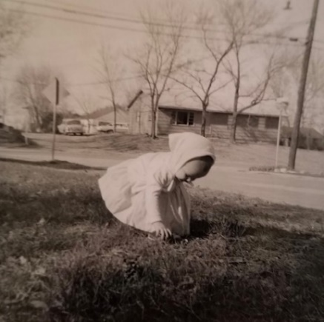 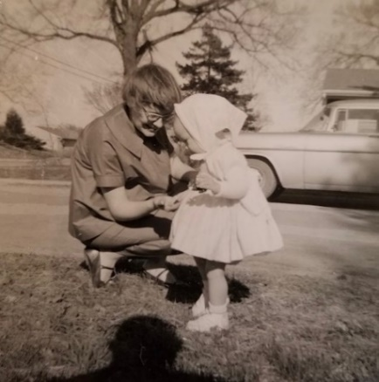

Lesle in her Easter outfit, March 29, 1959. Mom is pregnant with Lisa.

**4-1-59 – Wed Noon –** I’ll write this while I’m eating my lunch. Today is cloudy and rainy and yesterday evening we had quite a storm with a tornado alert. We are changing our plans somewhat and hope it works out OK for you folks. We will come (go) to Hutch the weekend following this weekend. It will work out better for us, I believe. Ruth had written her folks that we were going to Hutchinson this weekend and didn’t realize that Mr. Laidig has to be in Topeka this weekend for a meeting and that Mrs. L had decided to go along. We then had a letter from Mrs. L Mon saying that she had decided not to go along since we would be out of town. Ruth called home Mon night and Mrs. L said that Mr. L was gone and they’d have to decide later and that he would call. He hasn’t called as yet so we don’t know whether they’ll be here or not. Don brought home (from College of Emporia) an Iranian student and they will be there till next Mon, so she wasn’t sure she could leave easily. Mr. Laidig has been working hard to build Lesle a playpen so this would be the logical time to bring it on down.

Mrs. L lost out for the Kansas Mother of the Year. You probably read about the big mix-up they had. If that weekend is very inconvenient for you, give us a ring and if the Laidigs aren’t coming, we’ll go ahead as planned. By waiting till the 11 & 12th we can stay over till Mon morning, since everyone will be gone to Atlantic City for the meetings. We’ll drive down Sat morning and come back Sun morning (I think he means Monday morning.) and thereby avoid night driving and heavy traffic. We have a meeting this Sat morning about the student lab while there is none on the following Sat. It will look better if I don’t have to miss the meeting, etc.

We’ll be at home tonight and may miss choir practice tomorrow night. Last night Bob Legg (Ruth’s 3rd cousin) was up for dinner. He is a florest (Sp?) and about 30 and single. I got home early and helped Ruth get things ready. We had chicken fried a new way, peas, scalloped potatoes, etc. Lesle was pretty good, but, as usual, she got fussy near the end of the meal. I gave her a bath, which she always likes, just before Bob got there. Ruth put her to bed and we had dessert afterwards. We didn’t hear the tornado warning whistles till 9:00 and when we turned on the radio they said the alert was off. Bob stayed till 9:45.

We were home Mon night. Sun we were up early for the 8:00 service and then s.s. before the 11:00 service. Ruth got kinda fainty during the early service and had to leave before the sermon. She made it OK at the later service. It was hot and we weren’t fully awake. Lesle was good all morning but as usual didn’t take any nap due to the other children and all the excitement. After church we ate out and brought a lady home (teacher at the school up the street). We were home the rest of the day. Oh yes, our new address is 867 Shawnee Rd. They have changed the numbering since everything was all mixed up.

Ruth finished a new red outfit for Easter which looked real nice. Today she has cut out a top for another and said she had enough material leftover for an outfit for Lesle. She plays the piano at weekday church school, today. Today I’m wearing a new shirt which Ruth finished. I like it very much and she is making (later) matching shirts for Lesle and herself. Sat morning I worked here and in the afternoon we went downtown. I bought a new pair of shoes and Ruth a new hat and purse. We used some of her school-teaching money. Lesle, of course, still has plenty of new dresses which she is just now growing into. Later Sat afternoon I took the car for an oil change and we were home the rest of the day. Ruth went to the show by herself Sun night as I needed to study. Tell Aunt Clara (I assume she’s home) hello and M.J., and Bill and Uncle Clyde and we’ll see you all soon.

**4-8-59 – 4:30 – Wed –** I’ll mail this before leaving for home. We had a touch of winter this morning when it turned cold and snowed. Most of it is gone this afternoon but it is still chilly. Ruth did not go to church school today as she wanted to keep Lesle in. Lesle has had a touch of cold for some time and is now about over it. It was better we didn’t go last week-end as Lesle had touch of cold and Mr. L only came over on Sat and left Sun morning before we left. He brought Lesle’s playpen and that was about the best time for him to bring it. We’ve been home most of the time recently. We’ll leave as early as possible Sat but as you know we’re often delayed.

**4-17-59 – Fri morning –** It is rainy this morning and a little cooler after several warm days. We had a good trip home Mon. There was quite a bit of snow on the ground between Newton and Emporia. We left the things with M.J. and visited awhile. Jimmy was feeling much better. We stopped and got to see Bill just before he was leaving with a man. Ruth picked up some pamphlets there. Ruth drove all the way to Topeka where we ate lunch at the turnpike restaurant. I drove the rest of the way and we stopped in Lawrence awhile to see Mary Corman and to redeem some bookstore receipts. We got here at 4:00 just in time for one of Ruth’s pupils. Tell all hello. We enjoyed the weekend.

**4-22-59 – Wed 7:45 AM -** Lesle got up early this morning and since it was my turn to feed her I’m up early too. Lesle doesn’t take her early and late bottles quite as easily and wants to eat more and more at the same time we are. We aren’t buying any more canned baby food as she refuses to be fed almost entirely and, of course, she can’t feed herself with a spoon yet. Today will be somewhat warmer after two really cool days. Ruth is now finishing up a skirt so she can wear it to week-day church school today. There is a woman’s association meeting this afternoon which she will miss since the mothers are coming to visit at the church-school.

Last evening Ruth had circle at the house of our s.s. teacher. Mon evening she went shopping. Tomorrow evening she’ll probably go to choir practice. I missed last week and will probably miss most of the rehersals thru May so I can study. The choir is having the annual spring secular concert the 2nd week in May so I’ll try to make it for that. We plan to go to Mariners one Fri evening in May. Last Sun we all went to church and s.s. as usual. We have new lights in the s.s. room. After church we went to Katy for some sewing things and then back to the med center for dinner. We stopped by the Holladay’s on the way home and left the snow suit which Lesle had borrowed. They had some free vitamins for us. Last Sat morning I worked in the lab but I was the only one there as the professors were not yet all back from the meetings. They’re all back now. We were home the rest of the day Sat. as it rained. It’s been so cool that I haven’t put the screens up yet, or put Lesle’s play pen together. Glad to have your letter and tell Aunt Clara, M.J., Bill, Uncle Clyde and Jimmy hello.

**4-31-59 – Thurs 12:15 –** I’ll write this during the noon hour. Yesterday and today have been quite warm after rainy and cooler weather last week-end. Ruth says the heat bothers her quite a bit so we may have to buy an air conditioner before long. Lesle has enjoyed her playpen that Mr. Laidig made, and it makes it easier for Ruth when she’s working outside. We have several flowers now, including some of the bulbs that Mrs. L sent last year.

I just called home and Ruth said that your letter had come. We’re glad that your leg is doing better, but don’t overdo up at the apartment. This morning I went by the church to leave some tickets for the Mother-daughter banquet next Wed evening. Our class is sponsoring the banquet and since Ruth is treasurer she has charge of the ticket sales. She is also on the decorations committee and is making little bags of some kind. Yesterday was the last time for week-day church school so Ruth is glad. They gave her a milk glass bowl for playing. Today Ruth received a notice that her dad had subscribed to Good Housekeeping magazine for her. I’m singing a solo at the banquet and Ruth is playing for the fashion parade. I may sing “Irish Lullaby”. The men of the class serve as waiters.

Tonight is choir practice but I’ll miss again so I can study. Ruth will probably go, however. A week from Fri is the mariners meeting in Lawrence. I’m not sure yet of the exact time for the exams. It originally was set for the last, or next to last week in May, but the way things are going I could use an extra week. We were surprised last Sun evening when Ruth’s Mother drove up. She said she had “Just decided to come” and so did. She stayed till Wed morning. Tues night she took Ruth to a show. We ate at a drive in last evening. Last Sun morning was coffee so we made it to s.s. early. We ate at the med center afterwards and were home the rest of the day. Sat morning I was here, and then in the afternoon I washed the car while Ruth worked in the yard. Lesle was good all the time, while staying in her play-pen. Thats about all the news I can think of. Hope everyones OK and tell Aunt Clara, M.J. Bill, Jimmy and Uncle Clyde hello. I have written to that Ted Addleman in Oberlin about a week or so of work, but haven’t heard yet. Come here whenever you can. Grandmother underlined the last sentence.

**5-7-59 – Thurs noon –** I’ll write this while I’m eating lunch. Today and last night have been cooler and we even had to turn the furnace on for awhile this morning. I just called Ruth and she said your letter came and a card from her mother. I’m sorry. I’ve forgotten to send the pictures, I’ll sort out the negatives and send them on soon. Today is a lab demonstration so we don’t have quite as much to do in terms of setting things up, etc. My prelims will probably be the last week in May or the first week in June. Tonight is choir practice and I imagine that Ruth will go.

Mr. Denny is painting the house and fixing things up, but says he’ll have to raise the rent to $95. If he gets it looking nice I’ll guess it’ll be worth it. Our yard is a mess since I haven’t had time to work in it. We’ll have to hire it mowed, I guess, till I can get to it. Ruth said she sprayed some weed-killer this morning. Tomorrow night we plan to go to Lawrence for the Mariners meeting. We’ll see Mary and Gary, of course. Last night was the mother-daughter banquet. My solo went OK and Ruth played for the fashion show. The men of our class waited tables and Ruth had charge of the money. We took Lesle and she stayed in the nursery with one other little girl. Lesle can now get up fairly easily and is learning new things all the time. She was exposed to the little boy across the street who has had the German measles. Since she is so young the Dr. said for her to have one shot so if she got them it would be milder. We took her last Mon morning for that. She has seemed OK so far.

Last Sun we all went to s.s. and church as usual. We ate at home afterwards. Yesterday morning Ruth didn’t feel well so I went home and stayed till about 2:30. She had taken some cough syrup with codeine which might have done it. She had to make little hat boxes for the banquet and that took a lot of time. She had hoped to have a new top made for last night but didn’t get it done. Last Sat morning I studied here and in the afternoon we went to downtown K.C. Missouri. I guess that’s about all we’ve done of any importance. Tell Aunt Clara, M.J., Bill, Jimmy and Uncle Clyde hello. Did you ever receive any Blue Cross notices for us after last Oct or Nov. I paid 11-15-58 and filled out the change of address form but have not received any more notices. I’ve written them. Haven’t heard from Mr. Addleman in Oberlin as yet.

**5-14-59 – Thurs 7:40 AM -** Lesle started to awaken at 5 this morning so we’re all up much earlier than usual. She was up earlier yesterday morning, also. Lesle definitely has the measles today. She is quite broken out on and around the face. She had that shot so should have a mild case. She was exposed not only to the little boy across the street, but also, Ruth found out Sun that she had been exposed to a little girl in the nursery the week before. Both of them have had the 2 weeks measles so I guess that’s what she is getting. Today and yesterday have been much cooler which makes it nicer for Ruth and Lesle. We even have the furnace on this morning. Ruth is planning to go to choir practice this evening. She says “Thank you” for the gift. Aunt Clara’s and yours gifts will be ready a week from Sat. Grammy Laidig sent Lesle a new doll and purse which she likes very much. My exams are scheduled for the first week in June. Dean Wescoe would normally come (he was on Bob Volle’s) but he will be out of town, so they will write one of the other staff members.

Ruth missed choir practice last Thurs night. Fri night we went to Lawrence but found out that the Mariner’s picnic had been postponed till tomorrow night. We had thought we might go back tomorrow night, but now that Lesle has the measles I guess we definitely won’t. After we got there Fri we found out that Mary Corman had had a miscarriage and was in the hospital. It was nice, however, that we were there so Ruth could see her. We ate at the student union and I met and talked with some fellows I knew. One of the fellows thought that the Don Montgomery’s had a baby.

Sat morning I worked at the building and in the afternoon we went downtown. We stopped for Dairy Queen on the way home, which Lesle liked very much. Sun morning I stayed home with Lesle and Ruth went to s.s. Ruth says I can go this Sun. Ruth went to the show Mon night. Ted Addleman says he can use me the last week in July and the first week in August so we’ll plan on that for our regular vacation time. Why don’t you plan on coming here for some time the last of June or first part of July. Yesterday Ruth and Lesle went shopping with Mrs. Brownfield and bought some new material. I guess the sun started Lesle’s breaking out. Mr. Denny is working outside now. We’ve had to put up stakes as he’s been trampling the flowers. Please return the prints and negatives after you’ve had any you want made. Tell hello to all – Aunt Clara, M.J., Bill, Jimmy, Uncle Clyde. Glad your bandage is off.

**5-20-59 – Wed 7:30 AM –** We’re up a little early so I’ll get this written now. Ruth has finished the curtains for Lesle’s room. They look real nice and we hope she will sleep a little later in the mornings. When Lesle saw me starting to write this letter she decided she should write too, so I got her a pencil and paper. Ruth went to circle meeting last night and wore a new blue-flowered top which she had just finished. She said that she had several compliments for it.

My written major exam will be Mon June 1st. I had thought earlier that they would want me to write two or three days, however, they said they would try to limit it to 6-8 hours. My physiology minor exam will be on Wed the 3rd. They said they would send over only two questions for that. Two of the boys in microbiology, who took minor exams in physiology, each had five questions. These are long discussion type questions of course. The oral exam will be Wed June 10th. June 21-26 is fine with us for a visit here. Just let me know when you plan to arrive and we’ll pick you up, even at night.

Mr. Denny has finished most of the house painting and has installed two new aluminum screen doors which are very nice, so I guess it’ll be worth the extra money. I raked and burned leaves, etc., two days last week and yesterday took the lawnmower to be sharpened. Ruth said, just now, for me to put Lesle’s playpen up over by one of the flower beds, since she plans to weed there today. Lesle feels pretty good now and the rash is entirely gone. I guess it was lucky that we knew she had been exposed, as she could probably have been pretty sick. Hope you get one of the apartment rented. I stayed in with Lesle last Sat afternoon while Ruth went shopping. Sun morning I went to s.s. and church and Ruth stayed with Lesle. If you come in June the choir will still be singing. Yes, the red ball is Lesle’s. The prescription was for Achromycin, an antibiotic, to prevent any serious infection as a result of the cold. It has been hot here yesterday and today. I don’t dread these exams any more but it is getting rather tiring doing so much reading. I sang “Irish Lullaby”. Tell Aunt Clara, M.J., Bill, Jimmy and Uncle Clyde hello.

**6-1-59 – Mon -** Took my physiology exam today and will take pharm Wed with the oral a week from Wed. We rec. your letter today. Eldon Laidig and family will be in Oberlin a week so Ruth is going out on the train Wed morning. I’ll drive to Hutch Fri afternoon and on to Oberlin Sat morning and we’ll come back Sun. We’ve been fairly busy. Ruth made me a new shirt. We sang at a high school baccalaurate yest. afternoon at our church.

**6-14-59 – Sun 5:00 PM –** We were glad to have your card last week and trust you received your gift and card. We finally got M.J.’s birthday gift off at the same time. By the way, did I leave a silver clip-on tie-bar in Hutchinson the time we were there last spring. I forgot to look for it when I was there last week.

My trip to Oberlin went fine last Sat, although I was pretty tired by the time I got there. I stopped awhile, first, in Great Bend and had some lunch and then two more times along the way, Hoisington and Plains, I believe. Ruth, Eldon, Mrs. L and Lesle were at grandmother’s when I arrived about 4:30. Eldon had to be back by Tues so they left Sun about the same time we did. They planned to stay all night at Liberal and drive on to Austin, Mon. Eldon is attending summer school and plans to continue on for his Phd in education after writing his masters thesis next year. They were all glad to see us and I was glad I made the trip to see not only them, but you folks, also. Larry is so much larger than when we saw him last. Sat evening we stopped by the Addleman Drug Store and then took a high school graduation present to one of Ruth’s former drum pupils. She was in Hutch playing in the Lyons convention band. When I was getting the new tire I saw the Lyons parade from a distance. Eldon, Mr. L and I visited awhile later in the evening. Sun morning we all went to church together. Mrs. L kept Lesle since she was quite tired. She brought her down just as church was out and then we all ate at a café. Eldon and his family ate at the Urban’s (his wife’s folks) and they left from there. The preacher was on vacation and they had a guest speaker from College of Emporia.

Danny, Dallas, and Deloris were with us. Don is going to summer school (Emporia) to fill in some requirements he needed for the teaching job he took. David was on the farm working and he plans to go to Kansas Wesleyan in Salina next year. Dallas may go to Emporia State next year. We left Oberlin about 2:45 and arrived here about 11:30. I was more rested on Sun and drove all the way to Junction City, making it just at sundown. We stopped at Downs for Lesle’s milk. We made good time since the sky was clear and it didn’t get dark till later. We ate supper at a café in Junction City and Ruth then drove on to Topeka. That is the worst stretch for after dark since it’s not 4 lane. I put Lesle to bed in a backseat bed and then drove from Topeka here on the turnpike. I was pretty tired the first of the week from the trip.

I ran expts Mon, Tues and Wed. I stayed home Thurs morning and had my oral exam from 2-4 in the afternoon. It had been moved up from Wed. There were 5 profs there and I was fairly calm. Dr. Samson (from Lawrence) told them it was as good as any he’d ever been in on (including the written part). Good job Dad! Mon night we went to the store and I worked in the yard Tues night. We were home Wed night and Thurs night I practiced at the church for the wedding. The wedding was Fri night at 7:30. It was the wedding of Albert Evans (our bass soloist) and Ethyl Maxwell. He is 46 (his wife died 2 years ago) and she has been married previously and has a daughter in high school. Al has a girl 11 and a boy 15. Ethyl and her girl have been singing in the choir. There were 35 at the ceremony. I sang Beethoven’s “I Love Thee.” I sang Grieg’s “I Love Thee” at Ken and Elizabeth’s wedding and it was sung at ours. We all went to the wedding dinner afterwards and didn’t get home till 10:30. It was a nice evening after a wind and hailstorm Thurs during my exam. We had a babysitter for Lesle.

Yesterday morning I worked at the building till noon. Dr. Peters has left for a vacation in Minn and the Walaszek’s baby is due the last of June so I imagine he’ll be taking some time off then. We have several new people working however and a new graduate student is expected the first of July. In the afternoon we drove out to G.E.M. and got Ruth’s and Lesle’s vitamins at a big savings. In the evening we baby sat at the Brownfields (for their 2½ yr old) as the rest of their family (including her parents from Hammond, Ind) went to the older kids dancing recital. I started reading the clipping and Ruth watched TV. Lesle wouldn’t go to sleep till just about the time we left, at 9:45. We all went to s.s. and church this morning. Mr Blim (choir dir) is gone to Europe with his wife for a 5 wks trip and our teacher was gone so we met with another class. We ate at the med center afterwards and have been home this afternoon resting and reading. Let us know if you plan to come and tell Aunt Clara, M.J., Bill, Jimmy and Uncle Clyde hello. It’s 5:45 and we’ll drive down and mail this.

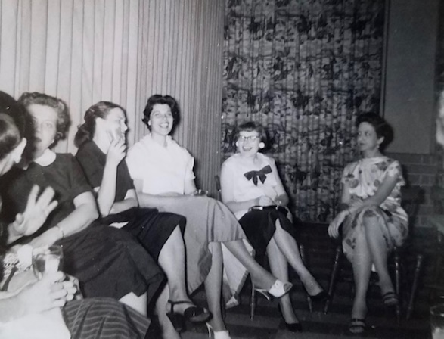

Not mentioned in the letters, but this picture is labeled June 1959.

Mom at pharmacology dinner, Golden Ox (a steakhouse in Kansas City).

**6-21-59 – Sun 8:40 PM -** I broke the Sabbath this evening and mowed awhile in the yard. Sinner! This could be the last time I ever mow this yard as Mr. Denny is definitely putting the house up for sale. An FHA man had been out about a week ago to appraise the house and the real estate man was out this afternoon. He says he is asking $13,500, which he thinks is $1000 too much. Nevertheless, even though he might have trouble selling it, it would undoubtedly sell before we’d be leaving. Denny, of course, says not to worry, etc. but he just doesn’t want to lose any rent before its sold. Ruth says she would rather move now than to wait it out – which would probably be about the time “Butch” comes. We drove around some this evening looking for for sale/rent signs etc. It will make it hard right now since there are no papers due to the newspaper strike. They’ll have listings of places at the Med Center. A new graduate student is due in our department this week. His name is Smith and he’s coming from South Carolina where he got his masters.

This morning our s.s. class had their annual picnic in Loose Park. That’s not the big park where the Starlight Theater is. If you stop here maybe we can all go to the Starlight. The picnic was at 8:00 AM and we got there about 8:25. We had a devotional and then talked awhile. Lesle got along fine and wore herself out, as usual. We went back to church and sang in the choir – it was certainly hot with the robes on. We ate at home today noon and have been here the rest of the time except for the ride. We stopped for some Dairy Queen’s on the way back. It has been awfully hot and humid the last few days.

My father’s day, short sleeved shirt (knit) which we got last Sat at GEM proved to be too small in the small size so we’ll have to take it back. Yesterday morning I worked at the building and we went shopping in the early afternoon. We came home and sorted through an old box full of letters and misc items. In the evening I did odd jobs and Ruth made a new top which she wore today. Last Mon evening we went shopping out at the Prairie Village Shopping Center. They have a new Jones store which is very nice. Thurs evening we went to Walt Disney’s “The Shaggy Dog” - it was very funny. We were glad to have your letter last wk and hope everything is going OK with the house work. Even though we might be moving in the next two wks, don’t let that deter you from stopping by here on your Wis. trip. My work in Oberlin is the last wk in July and the first in Aug. Tell Aunt Clara, M.J., Bill, Jimmy and Uncle Clyde, hello. P.S. Don’t worry about the moving. Thanks for the loan for the tire. Thanks for the father’s day gift. Let me know how much on that long distance call.

**6-28-59 – Sun 4:15 –** I’ll write this now as we’re having the Holladays for supper tonight.

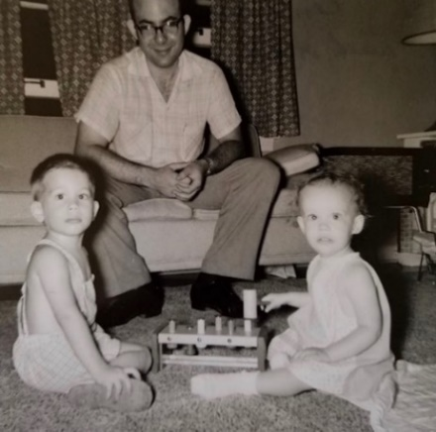 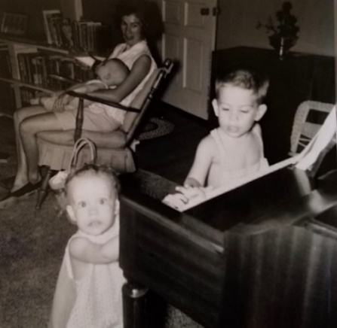 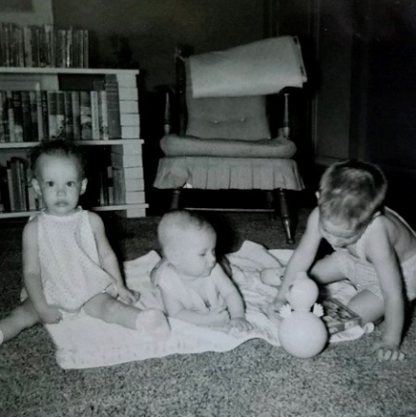

Ken and Elizabeth Holladay come for supper. Lesle plays with their son David, and baby Kevin.

Ken is thru his internship the 1st and they will leave for Ohio where Ken will be stationed in the air force. They have lived in that same trailer all this time and I’m quite sure they’ll be glad to get out of it. I just finished doing the dishes and Ruth is cleaning up the house. This will be the first company we’ve had in a long time.

Ken has to go south for a few wks of training and he’ll then have to spend about 2 yrs in the air force. Most of the M.D.’s enlist rather than wait for the dr. draft. I guess Richard Searl is in the air force, also. I must write to Henry Duerkson as I’ve never answered his Christmas note.

It has been cloudy and hot here the last 2 days, but no rain. It is supposed to get cooler tonight with the possibility of rain. I’m sure it would seem much hotter if we had decided to move. Last Sun evening we drove around awhile and then Mon evening we looked at some places. The Dr. said to either move right away or wait until 2 months after “Butch” is born. It has been so hot and since we didn’t find anything (we still have no newspapers) very satisfactory we decided to wait it out and see what happens. The salesmen for the real estate company, which is handling the house, were all out last Wed morning but we have had no appointments for people to look at the house and they have not put up a “For Sale” sign as yet. Mr. Denny is supposed to leave for Colorado the 1st.

Jerry and Chris Smith, the new graduate student from South Carolina, arrived this week. We may invite them for dinner this week, while the house is still in shape. Hugh and I helped him move his things from a trailer up to a 3rd floor apartment Sat morning. We all about wore ourselves out since the house was up some and it was the same as the 4th floor. Although he has not mentioned it, Ed says he has had ulcerative colitis and recently had his colon removed. One of his reasons for coming this far west is, supposedly, to get partly away from a very domineering family. They seem real nice and were married the day after we were.

Mrs. L wrote this week that she has an ulcer and is certainly not in favor of the milk and chalky medicine diet. We hope she has caught it in plenty of time for a good cure, but it may not be easy with the Musgraves. She has worked too hard with the Musgraves and they have been too great a nervous strain.

Lesle is fine but hasn’t been eating too well, so we bought a vitamin tonic which the Dr. recommended. We all went to s.s. and church today. It was communion and quite hot, but the last Sun for the choir. We ate at the med center afterwards and stopped by the store. We were home Tues, Wed and Thurs nights and Fri evening we went to see “The Firefly” at the Starlight Th with the Burfords. They brought their baby here and left it with our sitter.

Yesterday afternoon we went out to G.E.M. and exchanged my father’s day knit sport shirt for one of the right size. We were home yesterday evening. Hope everything is fine there and tell Aunt Clara, M.J., Bill, Jimmy and Uncle Clyde hello. We looked at a nice house, close to Med Center for $100 but not enough room for all our furniture.

**7-12-59 -** Ruth has just written a card to her folks so I’ll drop you a line, also. Today has been cooler, as it has been for the last couple of days. Lesle has been sleeping till 8:00 AM each morning since you left – which is the best she’s done in a long time. I suppose the cooler weather makes a lot of the difference. I hope it is cool there, and that Aunt Nellie and you have a good trip to the cottage – don’t overdo. You can let Aunt Nellie read this.

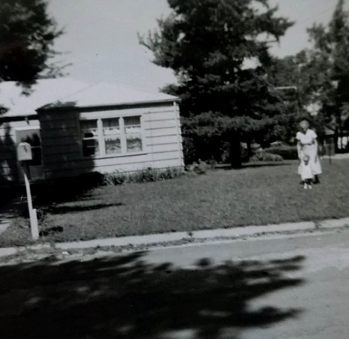 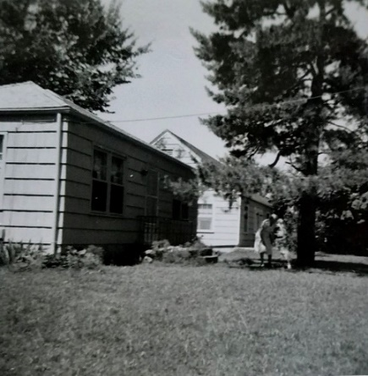

Grandmother in the yard of the house on Shawnee Road.

When we looked for this house in 2019 we only found an empty lot.

We keep thinking that the people who have bought the house will contact us, since they supposedly were quite anxious to take occupancy. Mr. Denny finally called Fri and told us that it had been sold. The downstairs of the house they live in (about 3 blocks away) is vacant, but we decided some time ago that we weren’t interested in living there.

We have all just finished eating some very good coffee cake which Ruth made. We’ll go to the post office and then come back for supper. I found Lesle standing alone on the back porch a while ago when I went to check. The screen was unhooked and she had made her way out. We must remember to keep it locked. We all went to s.s. and church this morning and it seemed so strange to be sitting in the audience during church. Ruth is playing a duet and a duo piano number next Sat at the psychiatric center someplace here. She is playing with Betty Graham, a church member. We ate at home and have been here the rest of the afternoon. Yesterday we didn’t do much in the afternoon since Lesle took such a good nap. Ruth got some needed rest also. We drove by to leave some baby clothes for the Holladays, but they were gone. In the evening we stayed home and did odd jobs and played one game of Anagrams – I lost, as usual. Tell Aunt Nellie hello and hope everything is OK.

**7-19-59 – Sun 6:40 PM –** We’ve just finished eating and will go for a ride in a little bit, mailing this letter then. Lesle has just finished drinking her milk, holding her cup all by herself and hasn’t spilled hardly any. She played real hard this afternoon, after her nap, while her parents were trying to read. She can now climb up on the davenport by herself and the other day I found her up on the piano bench. She loves to play the piano as you know.

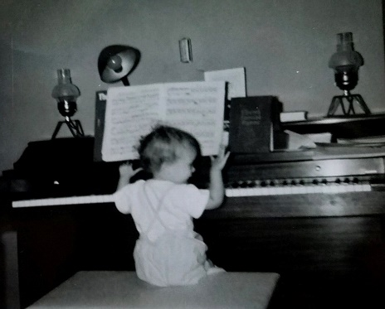

We all went to s.s. and church this morning, and were late to s.s. Mrs. Moyes, the preacher’s wife, had the devotionals and had wanted me to sing so I guess it was a good thing that I turned her down. She called yesterday and I just didn’t feel like I was in proper voice. We ate at home after going by a Katz drug store for some sewing things. Lesle is now crying as Ruth tries to clean her face.

We plan to leave for Oberlin next Sat morning so we can be there for Sun. I’ll work the 2 weeks as far as I know Working even during his vacation! and we may start back early Sun and plan to be in Lawrence by 4:00 to attend the wedding of one of Ruth’s friends which will be held in Danforth chapel. By starting early, both times, we should avoid any night driving. The people who bought the house have not contacted us, since they’re waiting to see if the loan comes thru, I guess, so I’ll call the real estate man this week and tell him we’ll start to move out the 2nd week in Aug and it may take us 1-2 weeks. We may move some flowers next week.

Yesterday I worked awhile and then babysat from 11:00 AM to 3:00 PM while Ruth went and sang and played with the church women as they gave the program for the psychiatric ward at General Hospital. They pass the programs around to the different churches and they said the attendance of 50 was the largest they have had. Lesle wouldn’t go to sleep till just before Ruth got home. She’s used to having Ruth put her down for her nap and would rather play when I’m here.

Afterwards I went by Gerald Bernstein’s uncle’s prescription store (boy in depart.) and he showed me the new drugs that have come out in the last year. We were home all the rest of the evening. Fri night it rained while we went to the funny show “A Hole in the Head”. We had our regular babysitter. Wed evening we ate out and went to the ice cream social at the church. Hope everything is fine there – our weather has been cooler and has been a real relief.

**7-28-59 – Oberlin, Ks, 1:00 PM –** Dear Mother and Aunt Nellie, I’m writing this while I’m on my lunch hour from work. Although the weather has been fairly warm here, it is not as uncomfortable as in Kans. City, however, where the humidity is so bad. This morning on the way to work we stopped at the hospital to have the stitches in my left thumb taken out. Last Tues noon as I was starting to run an experiment I pressed too hard on the stopper of a glass stoppered little cylinder and it broke in my hands. The result was a severed tendon in my left thumb which will take another 5-6 weeks for complete healing, like a bone. After the accident I went to the emergency room where one of the surgeons sewed it up. He put on a big bandage to completely immobilize my hand. The Dr. here took that bandage off this morning and put on a much more convenient splint. The other bandage was so large that Ruth had to rip out parts of my shirt sleeves in order to get the shirts on.

I couldn’t do any more lab work last week so I stayed home most of the time and helped Ruth as much as I could since she had to drive and everything. We ate at drive-ins so Ruth wouldn’t have as many dishes etc. to do. We left for Oberlin Fri noon just after I saw the Dr. and drove to Salina. We stayed in an air-conditioned motel and had a good rest. Salina is out of the way but Ruth was too tired to drive further. We arrived in Oberlin about 2:00 on Sat. Ruth “survived” the extra burden in fine shape and is getting a good rest here.

We went to church Sunday. I went with Mr. Laidig as he teaches the adult s.s. class. Ruth and her Mother came in time for church. Lesle stayed in the nursery with one other child. We all had a big dinner at the Laidigs afterward. Ruth’s Aunt Lenore was in Kans. City the day I hurt my hand and so took care of Lesle while Ruth was down with me. She was on her way here from Florida by way of Indiana. She is here now and was over for the dinner Sunday.

Despite the big bandage I made it OK yesterday and filled 24 prescriptions. We haven’t been very busy today, however. The older Mr. Addleman is here while his son is on vacation. Mr. A is 87 years old and does all the bookwork, waits on customers etc. They also have 2 girls working. Ruth and her mother went to the show last night while I stayed home and worked on my file. I’m using the break from work to catch up on my fileing, reading, etc. We’ll probably start back to Kans. City a wk from Sun. Since we have planned to stop in Lawrence for that wedding the Laidigs may also go along. It is the wedding of the daughter of the former superintendent and high school principal here. If Mother has left you can forward this on to her. We hope you are all well and are having a satisfactory time.

**7-?-59 – Tues 1:00 PM -** Dear Mother and Aunt Nellie, I’ll write this while at work and during the time we’re not very busy. Mr. Laidig and I were supposed to go to Rotary at noon but we found out just before time to go that the meeting will be tonight and is a picnic. Dott (the older man here) and Ted Addleman are both Rotarians also. The meeting tonight will be out at the lake. The lake is from a damming of Sappa Creek and was built by the WPA. Ruth and I drove out last Thurs night to hear the band concert (at the lake).

Tonight Ruth and Mrs. L will go to Rotary since its for the wives. I guess I’ll be able to go also. Ruth and I plan to visit the new museum and sod house some evening this week. This will be the last time I’ll write till we get to Kans. City. We plan to leave next Sun. I’m driving now and will probably be able to do some on the way back. I spent $26 on the car yesterday and had a complete 10,000 mile checkup. We were glad to receive your two cards.

The Dr. dressed my finger this morning. I now have full use of my 4 left fingers. I have not been slowed up at all here at the store. I can do some lifting etc. John Laidig (N.J.) and family will be thru Oberlin and Kans. City the latter part of Aug. He has to come west on business and will combine it with a vacation. Mrs. L’s double cousin and husband are here for a few days from Florida and are staying next door with Grandmother Williams and Aunt Lenore.

It has been real hot (up to 100) for several days. Lesle (and we also) slept better last night as we were tired from the night before when Lesle was up 3 times. She has been wanting a glass of water every night after we go to bed and disturb her. Her bed is in the same room as ours, of course. The house has even been warm with the air conditioner.

If you go to the cottage I hope everything goes fine and you have a good couple to take you. I went to s.s. and church last Sun and Ruth, Lesle and Mrs. L came for church. We had a big dinner again with Grandmother and Aunt Lenore.

Sun night Ruth, Lesle and I went to the drive-in for supper. Mr. L is here this week working at the school painting etc. He is really a hard worker, up early in the morning, etc. I can’t think of anything else very special. Mrs. Laidig goes to the Dr. for a check-up today. She feels fine now. Hope you all are fine and I’ll write from Kans. City. Stop by on your way back from Wisc.

**8-4-59 – Oberlin, Kans. – Tues –** Dear Aunt Clara, We’ve had a good vacation here except that it has been awful hot. Mother may have written by now that 2 wks ago today I cut the tendon in my left thumb and have to have it splinted. It hasn’t slowed me up at the store, however. We plan to go back to Kans. City next Sun and will then have to move. We plan to stop in Lawrence at 4:00 Sun for the wedding of the daughter of the former superintendent and high school principal here. Mr. and Mrs. Laidig may go too.

We’ve had several days approaching 100 degrees and Lesle has been restless and fussy at night, but really enjoys all the people around (?). Hope its not too hot in Hutch and your air conditioner is going. Mother writes that they may have a ride to Three Lakes. Have even done a little soda fountain work here.

**8-?-59 – Wed 10:00 PM -** Dear Mother and Aunt Nellie, I don’t know whether you’ll be back in Madison by this time or not. The weather has been hot here since we got back from Oberlin. The 2nd week of work went OK and I assume that Ted got back OK on Sun so that he could open on Mon morning. I averaged about 18 prescriptions a day for the 2 weeks of work. I charged them $225 which is cheap for relief pharmacy work. I felt that was enough, however, since I more or less asked for the job and they don’t do a very big prescription business. I dusted and cleaned the entire prescription department while I was there.

Thurs and Fri evenings Ruth and I visited the new (new in the same year I was new!) Decatur County Museum and sod house. Mr. L is on the governing board. After a few cool days early in the 1st week of vacation it was hot the rest of the time except for a day or so near the end. We were up and left by a little after 6 on Sun AM. The Laidigs followed us all the way to Lawrence. We ate breakfast in Phillipsburg and had lunch in Junction City. We were in Lawrence by 3:00 so we had plenty of time to get ready for the wedding.

It was very hot and since Lesle had had only 2 short naps she was very fussy and of course wouldn’t stay still when I took her into the chapel. I took her out and stayed with her during the entire ceremony. We walked around on the grass outside Danforth Chapel. Afterwards we attended the reception at the Holliday Inn Motel. The Laidigs and we ate at a drive-in and they started on back. They planned to stop overnight along the way. We drove on back to K City and were here by dark. I unloaded the car while Ruth visited with the Brownfields.

Ruth has been working hard getting things ready to move and she gave lessons yesterday and this morning. She got some sewing done in Oberlin and completed a dress for Lesle and a top for herself. I loaded the car Mon night and we took it down yesterday evening. This afternoon I left the building at 3:00 PM and we went to the house where I unloaded things and Ruth cleaned. The people were nice and left the house very clean. This evening Hugh Burford helped me move the rug and pad down. The rug is a little wide so I’ll have to cut it down some.

This morning I had my thumb checked and he thought another week with the splint would be enough. Tomorrow night or Sat we may go to the Starlight and leave Lesle across the street. In return we’ll take care of the Brownfield children on Fri night.

We plan to be moved by a week from today if possible. Our new address is 4442 Eaton St., K.C., Kansas. Hope everything is fine there and you are having or have had a good trip to the cottage.

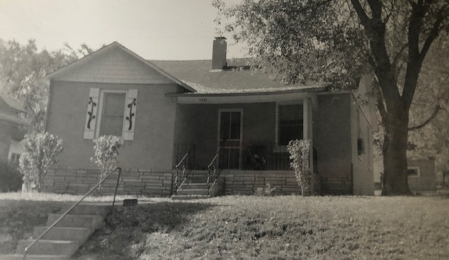 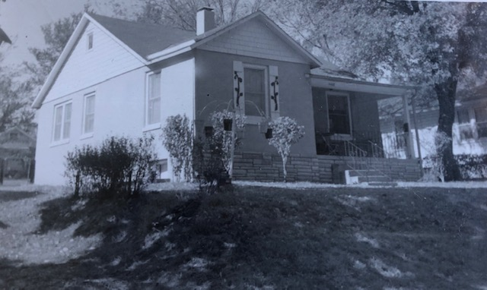

4442 Eaton Street, Kansas City, Kansas

**8-?-59 – Tues 11:00 AM –** I’ll write this while I’m at the building and have some time. It has reached 94 or 95 every day since you were here I believe. Ruth has stood it so far but is still pretty tired. I guess the sweating is good for the low salt diet, but it makes it hard to get much done because of the heat. We had a letter from the Laidigs yesterday saying that they had gotten back from Indiana OK. I guess Grandmother Williams stood the trip in fine shape. Because of her, and since they took a more direct Northern route, they did not come thru Kans City. They have not heard from John Laidig, although he was to be finished with his work in Salt Lake City a day or so ago. As I’ve mentioned, they’re combining their vacation with his job in Utah. They camp out and are supposed to stop in Oberlin and Kans City on their way back. We have plenty of room for them to set up their tent, etc. Lesle used her swimming pool for the first time yesterday at the new location and even ducked her head.

I hired the grass mowed last Sat as it had gotten too high for easy cutting. We have stored the empty boxes in the little house and put magazines, poisons, etc., on the basement ledge. There is a meeting of the choir officers for tonight so we’ll both go if can get a babysitter. Ruth has met a housewife across the street who is younger than I am and has 5 children with the oldest one 5. They are Catholic and are expecting a 6th. The people directly across the street from us move out Sun and another family has moved in. We may also go to the last Starlight Theater show this week, again, if we can get a babysitter. Our regular sitter has gone to camp but the lady across the street suggested someone.

Dr. Walaszek and 3 other professors will be going to the fall meetings in Miami which start next Mon. That is the same meeting that I went to a yr ago in Michigan. I might have got to go except for Ruth. I’m writing for some money today so that we can get the dryer before long. The basement is not wired for 220 volts but I don’t believe there is room for it in the kitchen.

Apparently the house on Shawnee Road has not been officially sold. Denny was out and said if we had listened to him when he said that “it wouldn’t sell” that we’d still be there. The FHA apprasal was lower than he wanted and I guess they couldn’t swing the difference. The real estate man said it might go thru later, however. Regardless of whether it sells or not we are glad to be gone because of the uncertainties and the difficulties with Denny. He did not remember calling me and telling me that he guessed the house was sold and that we had been good renters etc. Yesterday he called and wanted to know when I would be able to pay him the Aug rent. He did not remember that less than a week ago we talked and he said it was OK if I didn’t pay him right away etc. He drinks so much that he can’t remember what he says from one day to the next. Despite being more crowded we’re glad to get away from it.

Our new telephone # is TA (Talbot) 2-0932. The only service available in that part of town are 4 party lines so that is what we have. We were on a 2 party line before, I think. Yesterday evening Ruth gave me a haircut and we read awhile. Lesle has had heat rash but it is about cleared up now. Sun morning we all went to s.s. and church. It is nice to be able to drive to church in about 5 mins. I walked to work once and it took about 15 mins. I can drive here in about 5 mins. It was convenient Fri evening to be able to stop by the bank on the way home. Sun noon we all ate at home and then rested awhile. Later in the afternoon we took a long ride and then went by the house to get some more flowers. It was so hot and Lesle cried every time the sun got in her eyes while we rode.

Sat morning I came to the building and we went shoping in the afternoon. Last Tues night we ate at the Jerry Smith’s (graduate student). We then picked up the rented truck and with the help of the other boys moved the furniture. We slept on Eaton that night and the next morning the professionals moved the stove, etc. Cost of both the truck and the movers was $29. I took off the rest of Wed and Thurs and moved the last load from the house at 6:00 PM Thurs evening. I came back to work Fri. Lesle has learned a lot of new words recently. I talked to Ruth at noon and she said your letter had come. We were glad you were able to stop by on your way back from Madison. Tell Aunt Clara, M.J., Bill, Jimmy and Uncle Clyde hello. I got the bandage off my thumb last Fri but have quite a numb spot.

**8-?-59 – Thurs 7:10 PM –** Dear Mother and All, It has been a little warmer this afternoon after being real cool this morning. The cooler weather of the last 3 days has been a real relief after so many hot ones. Lesle has seemed more energetic since the cooler weather. Our first choir practice is one week from tonight. Ruth doesn’t really care too much, as she is hoping the Dr. is right when he says there is a good chance that Butch will be early. She’s ready any time. We’ll take Lesle up to the Brownfields when the time comes. We’ll probably go shopping for the dryer this weekend. We just purchased a 45 piece Melmac (unbreakable) dinnerware set from Wards. Lesle can now use a plate at the table with no danger of breakage. She eats fine with a spoon and tonight ate a big dish of ice cream all by herself

 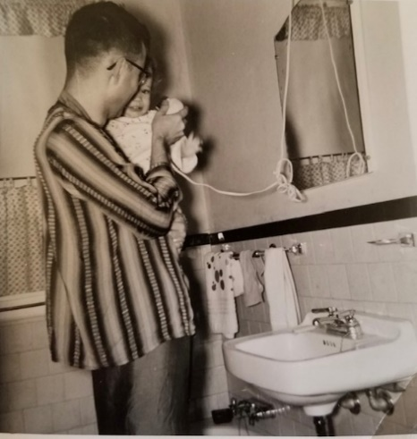

Lesle at 18 months. Daddy’s girl.

We all drove to work this morning and Ruth went to the Dr. while Lesle and I stayed at the lab. It was so cool this morning that we had to turn on the oven to heat the kitchen for Lesle’s bath. After her appointment Ruth took Lesle and they went to the plaza where they ordered some red carnations for Grandmother Williams 93rd birthday. Lesle had an appointment at noon and since she only weighs 18 lbs and 12 ozs the Dr. said to bring in a urine specimen to make sure that there is no infection. Tonight I’ll drive down to the Mo. post office and mail this after a bit.

Mon night we finished getting things in order for the John Laidigs. I stayed home Tues afternoon and helped Ruth. They arrived a little after 4:00 and put up their big tent in the back yard. They have air mattrisses to go under their sleeping bags and all 8 of them fit just easily in the tent. Ruth had a nice supper for them – I had to borrow 4 chairs to have enough. Tommy, the youngest, will be two in Dec, and Judy, the oldest, is 16. I guess she is quite smart and certainly does talk intelligently. We stayed up and visited till midnight and also some the next morning. They travel by station wagon and carry the tent and things on the top of the car. They got packed and away by 11:30 the next morning. They were planning to back track to Lawrence and spend the night with one of his old college roommates. They had spent 2 days each in Oberlin and Topeka (Mrs. J. L.’s home) before arriving. Lesle is now writing in and looking at that big drugstore book that Aunt Clara gave her. My hand lawn mower is just too dull for the grass so I guess I’ll have to have it hired done again. Ruth was so tired last night after the company, that we ate out. Someone told her today that if you drive after being pregnant 7 months that you can’t collect insurance in case of an accident. She, of course, has driven quite a bit.

Last Sat I didn’t go to the building as we did a lot of shopping and fixing things up here. We are now pretty much settled and have actually sorted thru a lot of boxes and things so that they are in much better shape than before. Ruth went up to see Mrs. Brownfield awhile yesterday evening after we ate. Apparently Denny has not rented or sold the house, as yet. He made me madder than I have ever been at anyone in my life when he hounded me for the Aug rent after he had said there was no hurry. We had not paid him as we had thought the house was sold and of course, did not know when we’d be out. I paid him $50 for the time we were there. Our total cost of moving, including the time for double rent, came to about $55, also including telephone installation. I thought that was pretty cheap. Ruth transplanted all the flowers she wanted and we brought some rocks down also. We’ve been very satisfied here so far. We all went to s.s. and church last Sun and stayed in Sun afternoon as it was so hot. I probably wrote of our choir officer meeting a wk ago Tues night. We went to the Starlight Thurs night to see L’il Abner. Jenne ? Leicht, the college girl who worked in our lab, babysat for us. Ruth went to the Brownfields Fri night. We went to 3 Starlights for the summer, wish you could have been here for one. Yes, we received the package OK and Ruth will be writing Aunt Nellie soon. Hope everyone there is fine. M.J. wrote they’d be here this weekend. Tell Aunt Clara and Uncle Clyde hello.

**9-9-59 – Lisa is born!** I was born at 9:24 AM, weighed 8 lbs, and was 19 3/4 inches long.

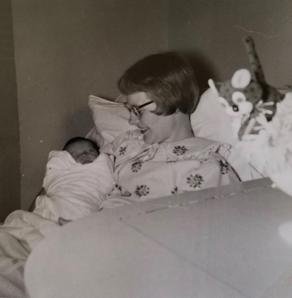 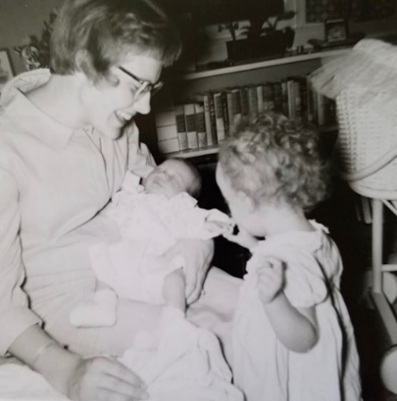

Lisa at 4 days old.

**9-16-59 – Wed 7:00 PM –** I’ll start this before I go to choir practice. We’re having choir practice tonight rather than tomorrow since Mr. Blim is busy then. After warming up over the week-end it has gotten a little cooler each day since. It is supposed to get into the 40’s tomorrow morning. By the way, our address is 4442 Eaton, not 4242. I, of course, planned to write earlier but just haven’t got around to it. Lisa and everyone is fine. She says “thank you” for the nice gift. Although we haven’t used it yet the dryer is installed and we all say thank-you to Aunt Clara. The weather has been so nice since Mon, when it was installed, that we haven’t had to use it. Ruth is invited to a shower, for Lisa, up at Mrs. Brownfield’s this Fri evening. It will be given by the neighborhood ladies, I guess. That will be the first time out for Ruth. She is gradually regaining her strength but is still pretty tired. Ruth is feeding Lisa and she eats every 3-4 hours, including nighttime, of course. She stays awake about an hr. each time she eats and sleeps pretty well the rest of the time. This is about the 7th time the baby basket has been used, I guess.

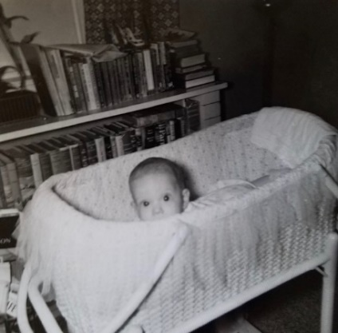

Lisa in the famous basket.

A week ago this morning we all slept late after having gone to the drive-in movie the evening before. Lesle was so interested in the movies that she wouldn’t sleep and, **henceforth**, was so tired that she slept late Wed morning. Ruth started in labor about the time we got up and I started taking my time when she said we better hurry up. I called the hospital and they said Dr. Spanos was already in that morning. I let Ruth out at the emergency entrance at 9:00 and took Lesle on up to the Brownfields as planned. When I got back about 9:30 or 35 I asked if they would ask Ruth a question for me. The nurse came back and said we’d had a girl at 9:27 – so you see it was pretty easy on me. Although fast, it was a little harder on Ruth, than with Lesle, as they didn’t have time to give her a spinal anesthesia. She only had some gas near the end. After they brought Lisa out, on the way to the nursery, I came home and made some calls. I first tried to call both you and Aunt Clara, then Ruth was supposed to help serve that noon the first womens meeting so I had to call about that. Later in the morning I went back to the hospital and saw Ruth when they took her to her room. She had the same room as the other time, only the other bed. It is a room designed for “rooming-in” (where the mothers are nursing) but was not being used for that at this time.

I spent the rest of the day running errands and spending that time waiting for M.J. I guess they had already left town when I was waiting. Mrs. L came Thurs evening. I brought Lesle home Wed evening to stay with me and took her back to the Brownfields (I’m now at the post office) Thurs morning. I hired a baby-sitter Thurs evening before I knew Mrs. L had arrived. It was better tho, because she had a good visit with Ruth and then came by the church and met me at choir practice. It was our first rehersal so we had refreshments and she got to meet some of the members. I picked up my birthday pants the same evening (from Ruth and Lesle) and am wearing them tonight for the 1st time.

Mrs. L has been a big help and I, of course, would have had to take off work otherwise. She promised her children she would come for their 1st 2 babies. Ruth sent a thank-you note to Aunt Nellie and she sent a nice note (well written) to us and a $1 to Lisa. Plan to come see Lisa whenever you can. She was 8 lbs at birth and of course lost some at 1st but was 7 lbs 5½ oz when she left the hospital. I’m sure she is gaining fine and will probably pass Lesle someday. She is so much fatter in the face than Lesle was. Sat morning and early afternoon I worked at the building and then visited Ruth. Later in the afternoon I had the oil changed and drove out to GEM for some things. I let Mrs. L visit Ruth once or twice each of those days while I kept Lesle. Sun morning I went to s.s. and church while Mrs. L and Lesle stayed home. Ruth and Lisa came home right after church. It was fairly warm. Both girls have been good since and Lesle has been pretty excited about it all.

Tell M.J. and Bill we were glad they could stay at our house and they were no bother at all. We’re sorry they got away before seeing Lisa. We were still in bed that morning when they left. Mon night was our first graduate course meeting which will go on during the fall and winter quarters as usual. My salary was raised to $260 a month and the research is finally beginning to show some interesting results. A government grant starts Nov 1 which will pay the graduate students tuition for the rest of the year. I finally read a big pile of clippings last night. I will finish them soon. I had let them go since the 1st of the summer. I looked thru and threw away a pile of old drug magazines. I plan to clear out a lot more as they’re a bother to move. I guess the other house is rented a couple of ladies although the’re not moved in. Tell Aunt Clara, M.J., Bill, Jimmy and Uncle Clyde hello. Are you getting a TV?

**9-24-59 – Thurs 6:30 –** We’re just about ready to eat supper and then Ruth and I will go to choir practice. Mrs. L thought she might leave this morning but has decided to stay till at least tomorrow. She has sure been a big help. She brought a bookcase with her when she came and has painted it for us. We’ll use it somewhere for the books which have no shelves.

We’re both going to choir tonight but I imagine that only one of us will go Sunday. We won’t take Lisa to the nursery for a few Sundays yet. I had signed up previously for Ruth and myself to go on the annual communion calling this Sun afternoon. I’m not sure yet whether we’ll be able to go or not. Last Mon night was a special lecture in place of the graduate course. Tues night Ruth and I went to the s.s. class officers meeting. Last night Ruth and Mrs. L went to the church for a women’s meeting. It was my first baby sitting with Lisa and I wasn’t too successful. She was awake all evening although she wasn’t crying all the time. Luckily they came home before too late.

Tell Aunt Clara the dryer has been in use every day since we’ve had a lot of rain the last few days. Last Sun morning Ruth, Lesle and I went to s.s. and church. We had a big class in s.s. and Ruth played the piano. Ruth sang in the choir and got along OK except that she was pretty tired the rest of the day. Sun afternoon Mrs. L took a ride to see some of the new homes on display. This week all the women took a ride.

Thanks to you and Aunt Clara for the birthday gifts. Lesle and Lisa gave me two new handkerchiefs also. I’ve worn my new pants several times already. We were glad to have your letter and clippings this week. I’m about caught up on the clippings. Lisa is holding the Similac better, now. She usually does OK if she has both kinds of milk at the same time. Yes, Ruth made it OK to her shower last Fri night. The women had gone together and got an infant seat. That is the kind for infants before they can sit, so their back will be straight. It also flattens out. We took the Brownfields 2 sets of Melmac (plastic) dishes for taking care of Lesle. Last night we got Mrs. L a rubber drainboard mat. Lisa got a pink sweater set, some sleepers, $1, pillow. Lisa is brunette (about the same as Lesle at that time) and has more hair than Lesle had. I guess her color for clothes doesn’t matter too much. Yellow, pink, blue etc. It has been warmer the last few days. I may have mentioned that we had a card from Leila. Tell Aunt Clara, M.J., Bill, Jimmy and Uncle Clyde hello.

**10-5-59 – Mon Noon –** I had meant to write a letter sooner but after receiving your letter stating that you’d be here, I held off. It rained most of yesterday but has not rained so far today. Ruth and Lesle went to s.s. and I went to church. Lesle stayed and I brought her home. Hope your plane trip is OK. I might try to meet the train but I guess you can make it in cab if I don’t. I don’t know when Laidigs will come for the baptism but probably the 1st or 2nd Sun in Nov since they’re best for the preacher. We may plan to go to Hutch some weekend about that time before there is real cold weather or danger of snow. See you this week.

**10-19-59 – 10:45 PM – Mon –** I, of course, had hoped to get this written earlier but just didn’t get down to it as things have been piling up. The last few days have been warmer again. We were glad to have your card and then your letter today. Ruth has been stiff the last few days and had trouble walking today. I think she has done too much cleaning on the walls in Lesle’s room where mildew has been gathering. We had been getting some mail for the Thomas (former tenents) and when they picked it up Mrs. Thomas said they had also had the same trouble. (Ruth now says her stiffness is not due to the wall cleaning, so I don’t know what is causing it.)

Henry D. called yesterday morning before I left and said they would be in town till today noon. I invited them out for a light supper, realizing that I would have to leave early for my 7:00 graduate course. At noon I came home and helped Ruth awhile as she was having trouble walking. I left work a little early and went by Mrs. (Dorothy) D’s parents house where they were staying. They followed me on out here in their car and we had a light supper. We were glad to see them since we hadn’t been with them since we attended their wedding more than 2 yrs. ago.

Sun Ruth went to s.s. and I went to church. We have all had touches of cold so Lesle stayed home Sun. It’s nice we live so close to church so that we can alternate that way on the same Sunday. We all studied and read the rest of the day. I took the car for gas in the afternoon. Sat morning I worked awhile after Ruth went to the store. In the afternoon Mary, Gary and Roger Corman (Ruth’s former roommate) came over from Lawrence. They’re expecting a baby on Mar. 12th, the same date that Lesle was due. She had a miscarrage not long ago but seems OK this time. We had meat loaf for supper as the butchers are striking and there was little other meat available. Lesle and Roger got pretty well acquainted again and played while Ruth and Mary did some shopping together.

Ruth goes to circle tonight and I have that other class this Thurs. The Laidigs plan to be here this weekend for Lisa’s baptism. The next Fri we’re in charge of the games for the s.s. class Halloween party. We may plan to make that trip the next weekend if everything works out OK. Bill called last Sat afternoon when he was here with the kids and I told him that might be the weekend. Hope everyone is feeling better there. Ruth says this morning she has a numb spot so it may be things slipping back in place causing her stiffness. She had a numb spot in her back while she was carrying Lisa which the Dr. checked.

A week ago Sun we visited the neighbors to our North and the Walazeks, to see the new baby. Mon night was my class and Tues Ruth went to Brownfields. Wed Ruth went to the show and Thurs I went to choir practice. Fri night Ruth went to Brownfields. Glad you could come and we’ll see you all in about 3 wks. Tell Aunt Clara, M.J., Bill, Uncle Clyde, Jimmy hello. Mom adds: Lesle has added a very definite “l” to her sounds, so now she says lock, lap, lamb, lie, lamp, etc. And Lisa drank 7 oz last night for the first time – she really is a little pig! Guess that’s all I have to add for now.

**11-1-59 – Sun night 10:20 PM –** I’ll start this tonight but will not mail it till after we hear from you. The last few days have been considerably warmer, here, but the leaves are now turning color and falling in considerable numbers. As usual, I’m snowed under so probably won’t get them raked. We’re all feeling better, now, although I’m sniffing a little tonight as if I were getting some cold. Ruth’s stiffness is practically gone – I guess she had a touch of the flu. The mother of her two piano students had a cold the past week and therefore couldn’t bring them for their lessons. Ruth said tonight she might tell her former band instructor (he now teaches at Argentine High School, K.C., Ks) that she could give a few drum lessons this winter. Ruth is now working on some games for our s.s. class Halloween party this coming Friday night. We’re in charge of the games and entertainment. If it hadn’t been for Lisa’s baptism, today, we might have gone to Hutch this weekend so I could have gotten some magic for a show at the party. I may try to borrow a trick from a medical student who does magic.

Tomorrow night is our graduate course and my hour lecture is only 3 weeks off. I have just barely started and also have 3 nursing student lectures the 1st week of Nov. We can go to Wichita and Hutch either of the next two weekends. Right now, it looks like the 2nd one (Nov 7th and 8th) would be best for me because of the lectures. However, if someone will be gone or has something planned on the 7th and 8th we could come next weekend. We would leave on a Sat morning and go to Wichita (if they’re there), then Newton and Hutch. We wouldn’t come back till Mon morning to avoid the Sun traffic and night driving. Have to be back, of course, for Mon night. Let me know right away if this weekend would be best for you.

Yesterday morning I went to the building and in the afternoon baby sat and listened to the football game while Ruth went shopping. She purchased some very nice new shoes and a new purse. I had said I didn’t like the real sharp toes, so she got slightly modified ones ha! The Laidigs got here about 6:30 but had already had their supper. Mrs. L had been in Salina Thurs, Fri and Sat morning for the State Garden Club meeting and Mr. L. left Sat morning about 9:00 and drove thru Salina to pick her up. They visited awhile and then went out to see the Mahons (former Oberlin HS principal). They were tired but Mrs. L helped with washing dishes and this morning they planted some flowers they had brought. They brought a lot of papers and magazines which Ruth took to the Brownfields this afternoon. Their daughter collects them for scouts.

This morning Mr. L and I went to s.s. and the women came for church. Lesle went to s.s. with us. Mr. L. assisted (as a Presbyterian elder) in the baptism and Lisa was very good except for a burp. Ruth took Lisa to the nursery.

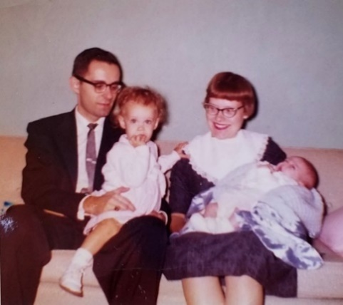 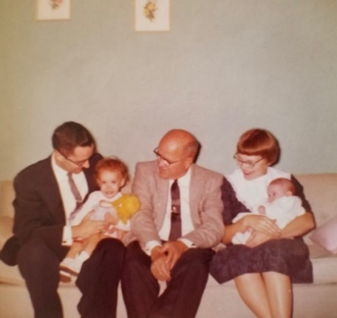

October 26, 1959 – Lisa’s baptism

Tues noon – we all ate out at the med center and they left immediately for home. We were glad to have your letter yesterday. I have already explained how we would leave on Sat and come back on Mon. I imagine there would be room for you in the car if you wanted to go over to Wichita and ride back with us. Last week I went to my extra class on Thurs night and Ruth went to the Brownfields on Fri night. I guess thats all of the major news. We all still have traces of cold today but nobody clear down. The girls go to the Dr. tomorrow and Ruth on Thurs for her final checkup. Lisa is getting fatter all the time. Tell Aunt Clara, M.J., Bill, Jimmy and Uncle Clyde hello.

**11-2-59 – Mon 10:30 PM –** I’ll start this tonight and finish it tomorrow. I got home about 9:30 from our graduate course. We had a guest lecturer from the University of Utah. My lecture is two weeks from tonight and I haven’t done anything on it since a wk ago. I finally got a good start on the nurses’ lectures. The first one is 12-1 Thurs, the second 1-2 Fri, and the third a wk from tomorrow. I’ll work tomorrow and Wed nights on the nurse’s lectures and then we’ll either go to choir or I’ll go to my extra class on Thurs. We’ll need Fri night to get ready for the trip. Ruth has just about finished Lesle’s new red winter coat. Mrs. L sent Lisa two pairs of booties today. We have all had colds. Ruth has had a touch but hasn’t had the runny noses like the girls and I have had. When you have children it is so much harder to get everyone free at the same time. Lisa gets quite wheezy at night but has been better today. Lesle is better and she played outside this afternoon.

Yesterday Ruth went to s.s. and I went to church. Lesle has missed 2 of the last 3 wks because of colds. In the afternoon and evening we rested and read as usual. Ruth gave me a haircut in the evening. Last Sat morning I went to the lab as usual and in the afternoon baby-sat and listened to the football games. Ruth went by the library and the Brownfield’s where she had Mrs. B help her alter a dress of her grandmother’s. We stayed home Sat evening. Last Fri evening we had a baby-sitter as we went to our s.s. class Halloween party at the church. As I told you a wk ago we had charge of the entertainment which everyone seemed to enjoy. Last Thurs evening I had an extra lecture and we were home on Wed evening. Last Tues evening Ruth went up to Brownfields and I spent most of the evening taking care of the girls. Mon was, of course, my class. We’ll plan to leave here as soon as we can next Sat morning but as you know its hard to predict exactly what time. We’ll probably eat at one of the turnpike restaurants at noon. We’ll drop by Aunt Faye and Uncle John’s first and then by Uncle Clydes. As I said last week you can plan to be over there if you like and we’ll make room for you on the way back. Mon 5:30 – I called Ruth at noon and she had received your letter. Since you’ll be at Uncle Clyde’s first we’ll go there first, also. I don’t know where the turnpike exit is, but I’m sure we won’t have any trouble getting there. Our colds are all better today and Lesle played outside this morning. See you all this weekend.

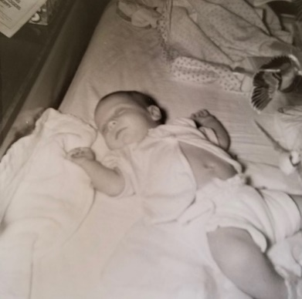 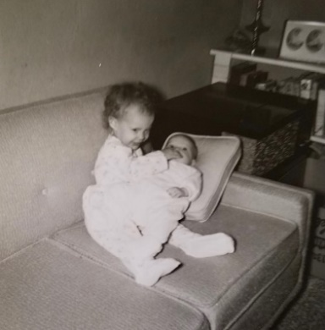 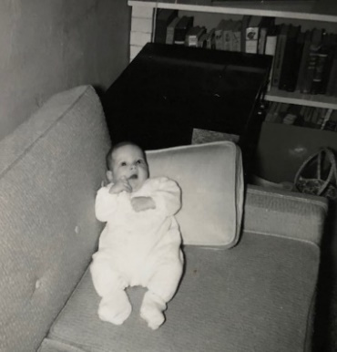

Lisa Joy at 2 months

**11-17-59 – Tues 3:30 PM -** I came home early today so Ruth and Lesle could take a load of washing to the laundromat. Our washing machine gave out the other night and the repairman won’t be here till tomorrow. We were glad to have your letter yesterday and card today. Our weather has been warmer the last few days, also, and today is clear and warm. Ruth and Lesle will go by the Brownfields awhile, while the washing is going. They plan to come back by here and then mail this letter on the way down to the library where she’ll return some books. I was just interrupted by the repairman and it looks like the motor has gone bad on the washer. This will mean a rewiring job and $20-30. I guess we can’t complain as it has given good service for almost two years and has been used as much as 4-6 times daily, recently. He said it would probably be the first of the week before the motor would be finished, so we’ll have a lot of trips to the laundermat.

I finished my third nurses lecture this morning and gave it from 1-2 this afternoon. It went OK and I’m glad to have them out of the way. They were good experience, I guess, but sure came at a busy time. It was hard to know what to give them as only three lectures to cover all anti-infective agents (antibiotics, etc.) and they certainly don’t need to have as much as if had been for medical students. Tomorrow I’m up in our regular seminar and may have to talk the entire hour. Tonight I’ll also work on my graduate course lecture next Mon night, which I’ve just barely started. As you see it was probably better that we didn’t go last week-end and probably better that we don’t plan on going next week-end. Ruth called the Dr. today and told him that Lisa’s sniffles were somewhat better but that she still definitely had them. We have stopped the antibiotic and if she’s not better in a few days she’ll call again. No, I don’t think she’s been bad enough for it to get on her lungs, she apparently has not had any temperature. The Dr. said for her not to go to the nursery till she’s 4 months old. However, if she’s better and the weathers OK we might possibly come on the 21st. We’ll let you know. Lesle is free of cold and went to s.s. and church last Sun. I’m still slightly hoarse and still cough some and runny nose. I coughed quite a bit during my 2nd lecture and some today, also.

Tomorrow night is the dinner for the canvassers who will call next Sun afternoon for the 1960 pledges at church. As usual, I plan to go calling but may not go to the dinner because of my lecture. Thurs night is my extra class but may not go again. Yesterday I ran an experiment and came home a little bit early so Ruth and Lesle could go do the laundry. I had class from 7-10 (ran late) and afterwards Hugh Burford came by and we looked at the washer. He has had some electrical experience but couldn’t see what was wrong etc. Sun morning I went to s.s. and had the devotions and had trouble leading the singing because of my throat and we had no piano player since Ruth and the regular substitutes weren’t there. I came home after s.s. and Ruth made it to church in time to process in with the choir. Its nice we live so close so we can both go each Sun and it looks like we’ll have to do that for another couple of months. We all rested awhile Sun afternoon and later Ruth and Lesle went to see Mrs. Brownfield and her younger sister who is visiting from Chicago.

Sun evening I fiddled some with the washer and blew a fuse and since they take a special kind we didn’t have some of our lights until yesterday evening. Sat morning I worked at the building and in the afternoon listened to football games and baby sat while Ruth did her usual shopping. Sat evening I got some work in on my lecture. Last Tues and Fri evening I baby sat while Ruth went to the Brownfields. She has finished Lesle’s new red winter coat which she wore for the first time Sun. Thurs evening I stayed at home while Ruth went to choir practice. That’s about all we’ve done since I wrote last. I’ll have to get Lisa up in a little bit as she hasn’t eaten since 11 this morning. I fed her this morning and she threw up most of it all over the floor and myself. She sometimes does that when she doesn’t burp well. The antibiotic upset her stomach and intestines some, also. Recently she has been sleeping thru at night till 6 or 7 in the morning so we’ve been getting more sleep. We had a note from Aunt Nellie, also. Mom adds: Have you any gift suggestions for Aunt Clara and Mary Janet? Would Mary Janet like some accessories (such as collars, scarves, gloves, etc.) that I could make? And if so, what are their favorite colors? Carroll can’t give me much help on these two. I’ll drop this at the P.O. now.

**11-24-59 – Tues 10:35 PM -** Ruth has just come back from her circle meeting and is doing the dishes that I didn’t get to this evening. I guess I’m not a very good baby-sitter, but it always seems to take my entire evening when I do it. Lisa is always wanting to eat quite a bit in the evening – but we can’t complain as she has been sleeping clear through till 9 or 10 in the morning. I usually keep her up most of the evening so she’ll be plenty tired. Lesle was up once after she went to bed as she has been doing just about every night – sometimes in the middle of the night. We were glad to have your letter today and to hear about everything. We had thought we might come this weekend but I guess we won’t be able to make it. Lisa still has her sniffles and it is now almost 3 weeks. Dr. Lum (in the department) said its not too uncommon for them hang on that long but Ruth will call the Dr. again Thurs if they’re not better. I’m still somewhat hoarse but not as bad.

The graduate students and their wives have been invited out to Dr. Huggins for dinner Sat night. We have never been out to their house although I did help him move in when I was working here that other time several years ago. We’ll have to hire a baby-sitter, of course. The other two students (Burford and Smith) are, of course, quite far from home and aren’t able to go home for Thanksgiving, Christmas, etc. so I imagine that’s one reason he’s having us all. Sat night is also our s.s. class bowling party which we’ll have to miss. Our evenings are all taken up this week so I really need this week-end to catch up on some things. You have an invitation to come this weekend or Thanksgiving if you would like. You haven’t said if you’re planning to go to Columbus with M.J. and Bill or not. We’ll plan to spend several days in Hutchinson around Christmas time and probably before going on to Oberlin.

The motor for the washer is not back yet. It has really made it inconvenient to have to take the washing out. It should be here tomorrow as the man had said Mon or Tues. Yesterday I worked on my talk during the day and then the graduate students took an inventory of the stock and glassware in basement. The new wing will be ready to move into about Jan 1st and they need to know what lab supplies we have in stock so they can order more for the new labs. My talk went OK yesterday evening. My voice held up better than it did for the nurses’ lectures. Dr. Walaszek ran about 15 mins over and I had a full hour plus discussion so it was 10:00 before we were thru (started at 7:00). His only criticism and I told him it would be mine too before he could tell me, was that I didn’t use the board and walk around enough. I just didn’t have time to go over it and really learn it well. Parts of it I hadn’t read over before I got up to give it. It was the same way with the nurses’ lectures. If one were teaching regularly there would not be the pressing lab work during the day to take your daytime. I have to do all the lab work during the day or I’ll never get done.

This evening I got home at 5:30 and Ruth and Lesle rushed out to do some laundry and then took a doll up to Mrs. Brownfield. Ruth made 2 outfits for the doll which goes to an orphanage – sponsored by girl scouts and Mrs. B daughter Mickey is a member. Ruth came back fixed supper, I went out and got dry wash, and then back and Ruth gone by 7:20 for circle meeting at which she had devotionals. She also had devotions last Sun morning at s.s. She got home tonight about 10:00. It was somewhat warmer today after 3 very cold days. We had some snow flurries last Fri but didn’t get the 4 inches predicted earlier. I walked to work last Fri as I thought it would snow. Tomorrow night we’re going to see the movie South Pacific – we have a babysitter. Thurs night Bob Legg (Ruth’s distant cousin) is coming over for dinner and Fri night I imagine Ruth will go to the Brownfields, so you see we’re quite busy also. Last Sun I didn’t go to s.s. or church. It was my turn for church but I had the every member canvas dinner at 12:30 and I was hoarse so I let Ruth and Lesle go to both. I had 6 places to call on. I got 4 pledges, one wasn’t at home and I’ll have to call back tomorrow and one wouldn’t pledge. In the late afternoon Sun, Hugh and Dot Burford came by to see the baby. I studied in the evening. Last Sat I went to the building in the morning and listened to the football games in the afternoon. Ruth went shopping alone and for groceries with Lesle. We were home in the evening. Last Fri evening Ruth went to the Brownfields and on Thurs we hired a babysitter – I went to the library and Ruth to choir practice. We were home Tues and Wed nights. I talked on my research for last Wednesday’s seminar. Guess that’s about all we’ve done. Sorry we can’t come but maybe it’s for the best. Tell Aunt Clara, Uncle Clyde, M.J., Bill and Jimmy hello. Mom adds: What size does Mary Janet wear and does she want a blouse to go with light brown, brown, red brown or what?

**11-25-59 – 9:45 PM – Wed -** As usual I’m late getting this letter started, but it has been a busy time, again. It seemed strange to buy envelopes at the store this evening. We’ve used nothing but those magic envelopes ever since we’ve been married. I did a trick for Lesle the other day and now she can say magic. She is learning new words and things all the time. She knows about half the alphabet and about 7-8 colors. We’ve been using the Anagrams and Chinese Checkers marbles to teach her letters and colors. She has been quite fussy the last few days and is requiring more comforting than usual. Partly on account of Lisa, I guess. I’m staying home tomorrow and we’re having the other two graduate students and their wives in for dinner at noon. They’re bringing the salad, coffee and dessert and we’ll have veal cutlets – something that Lesle will eat, I hope. We ate out this evening (2nd time since Lisa was born – 1st time was at Med Center when Mr. and Mrs. L were here) and Lesle was fussy and wouldn’t eat hardly anything. She had had a lot to drink beforehand and just wasn’t hungry.

In the morning I’ll take this and some other letters to our sub-station post office box and then help Ruth finish cleaning the house. I’ll have to study tomorrow evening for our graduate student discussion group. It was supposed to be today but Dr. Peters (he’s the faculty member for this one) wanted it Fri as he didn’t feel quite up to it. Fri some girl is coming from the veterinary pharmaceutical house Jensen-Salsbury and I’ll show her how to set up the guinea-pig intestine which, as you’ll remember, you saw the bath set-up etc. I have lots of work for the week-end as usual and then must start studying for our course exam 2 wks from today or tomorrow. Thank goodness, it is one of the 3 remaining exams I’ll have in graduate school. Yesterday evening we had a babysitter and went to choir practice. We’re rehearsing for our around the table carol sing (same as last year – John Laidig was here for one of them then) to be held Dec 9th and 10th. Things will be a little less rushing after that. Yesterday evening Mr. Blim said Ruth should try to hear the famous organist Richard Ellsasser who appeared at the K.C. Mo, Junior College this morning (Mr. Blims Dean, you know). The lady next door baby-set till 11:30 and I walked home (Ruth had taken the car) and then Ruth was back a little after noon. She said he was marvelous and I’m glad she got to go. She says she’d like to take some more organ lessons someday when we have more time and money.

Last Mon was our final meeting of the 1st quarter graduate course. We’re off next Mon night and then the 2nd quarter course starts the following Mon. As you remember the graduate course only occurs the 1st and 2nd quarters and the 2nd quarter course this year will be my last formal course to take. The research is coming OK and I’ll definitely go to the Federation Meetings in Chicago next April and present a paper. We now have government money that will pay travel expenses for students. Formerly, you just about had to be giving a paper in order to get approval for travel money. Last Sunday morning we all went to s.s. and Lisa stayed in our class. Ruth had to go as Mrs. Moyes (preacher’s wife) was in charge of the devotions and she had asked me to sing a solo. She was sick and couldn’t be there and so I sang and another fellow read a poem. After s.s. I took Lisa home and Ruth and Lesle walked home after church. The weather has been warmer the last few days but is supposed to get colder and snowy the next day or so. We stayed at home the rest of the day Sun and rested and studied.

Last Sat morning I worked at the building and in the afternoon listened to KU lose to Missouri and thereby, a trip to the Orange Bowl game. Sat evening we went out to Dr. Huggins with the other graduate students. We had a sitter. They had a nice dinner and we all enjoyed it. I did some tricks but it had been so long that it made me real nervous, even tho it was among friends. We were home last Fri evening. Thurs evening Bob Legg was over for dinner and stayed till after 10:00 PM. Wed evening we went to South Pacific. It was in Todd A-O (similar to Cinerama) we had to close our eyes for part of the introduction which was the usual roller coaster ride etc. We both get dizzy easily. I guess I had written up to that point last week. Ruth had circle last Tues night as I mentioned. 5:30 PM Thurs – The students and their wives have left. Lisa still has some sniffles but is much better. She has not had any temperature we know of. Glad you finally got the TV – there are times when we wish we had one. I haven’t heard the Baptist Laymen’s Hour but have heard about it. You might give the clipping in the other envelope about Cottonwood Falls to Leila sometime. One of the ladies I called on during the every member canvas – Mrs. McKee, has a son practicing medicine in Cottonwood Falls. I couldn’t think of Leila’s brother-in-laws name (one killed?). We thought about you today and hope you had a nice Thanksgiving. Ruth and Lesle went to library Sat afternoon. Lesle gets books also. Lesle’s books are her favorate “toys.”

**12-2-59 – Wed 1:00 PM –** I’ll start this while I’m still at home this noon. A check came through the mail so I came home and will stop by the bank and post-office on the way back. I’m not running an experiment today so am getting caught up on some odd jobs. Ruth is finishing a mail order for toys etc. from Aldens in Chicago. We just don’t have time to go out for much shopping and she likes to order from catalogs since she can study them over, etc. in advance. The last few days have been a little cooler but not that bitter cold we had for awhile. Mon night was free as we had no graduate course – it is between quarters. Fri morning I studied some and Ruth and I played a game of Monopoly. That was the first game of that either one of us had played in a good many years. Tues night Ruth went to the library, drug store and Brownfields and Wed night Ruth did some grocery shopping. Last night we had a babysitter and both went to choir practice. It was a big rehersal for the annual around-the-table carol sing and dinner next Wed and Thurs evenings. The choir is invited to the dinner on Thurs evening. It was a year ago, at the carol sing, that John Laidig was here from New Jersey overnight and therefore, went with us. They are having another rehersal Mon night but I have the first class for the 2nd quarter graduate course and Ruth is going to a baby shower. Some former Oberlin girl, I believe.

Next Wed is Lisa’s appointment at the Dr.’s. She still has a touch of sniffles part of the time but is certainly much better than she was. Wed is also our exam for the graduate course. The four students are getting together tonight at our house for a review session. We may have another one next Tues night also. Tomorrow morning I have to do my part of the grading on the last med students’ exam. This exam had write-in answers so the graduate students have to grade them. Usually they have questions (multiple choice, etc.) so that the secretary can do the grading. Sun morning is my turn for s.s. and Ruth’s for church. A week from tonight is our s.s. class Christmas get together. We work on some worthy project after having dinner at different houses. You see, as usual, we’re like you and always on the go. Last Sun Ruth went to s.s. and I to church. Lesle went for both and I brought her home afterwards. We spent the rest of the day as usual. Last Sat morning I worked at the lab in the morning and studied some the rest of the day. Ruth and Lesle went to the library in the afternoon. Lesle fell asleep before they arrived home and had to be awakened for supper. Last Fri night I stayed home and Ruth visited a neighbor.

The way things look now we’ll go to Hutchinson the week-end of the 19th. We may try to go through Wichita as we had previously planned. We’ll stay till the middle of the week before going on to Oberlin. If the weather should be bad we might wait and go to Oberlin first and then back through Hutch. We were glad to have your letter this week but sorry to hear about Isabel and Lee Hammond. I can remember being in the classroom when (8th grade?) Miss ? Kent had an attack and died. You didn’t say if Lee had had an attack or something on that Fri night. Sorry Bertha couldn’t get over for Thanksgiving. Lesle says about everything you could expect her to now and learns something new every day. Hope everyones OK and tell Aunt Clara, Uncle Clyde, M.J., Bill and Jimmy hello. The picture was taken by Mrs. L when they were here, the day Lisa was baptized.

**12-12-59 – Sat afternoon –** I’m about a day or so late getting this started but as you know we’ve had a busy week. Today is clear and warmer again after a couple of rather damp and cool days. I’ve been wearing my Christmas present from Ruth the last few days. It is a new spectator type coat - light tan, medium length, fur collar and real warm. My old coat with the fur collar which I had worn all the way through college is about completely worn out and looks more boyish anyway. This coat can be worn over a suit coat also, and is fairly dressy. My old brown top coat (first one I ever had) wore out some time ago and we gave it away. My other, newer top coat is beginning to wear out also. I won’t get another one this year, however, as it’s still plenty good yet. Ruth is finishing the sewing on some Christmas gifts, etc. She has a lot of packages already wraped so I guess we’ll be ready.

I worked at the building this morning and early this afternoon an insurance man called. He is one Hugh bought some insurance from and so Hugh gave him my name. There are some possibilities for savings on my policies by converting to insurance without the accumulation of dividends etc. and Ruth has two policies also on which there may be some chance for saving. He, of course, wants me to use the money saved by the changes to go for a new family plan that would cover Ruth and all the children one might ever have. I made no commitments and will wait until we check around some more before doing anything. It would actually mean at least a slight increase in output for insurance and the way we are now just the savings on premiums would, itself, be welcome. Ruth has now gone to the library and Lisa is asleep. Lesle was supposed to go with Ruth but she is still asleep (5:00) – she didn’t go to sleep till late this afternoon. Both girls seem to be getting touches of colds again, but I hope they’re not as bad as last time. We just can’t all seem to stay clear for any great length of time. We’ll both be home together tonight for the first time since last Sat night. We have been planning to go to Lawrence tomorrow to visit the Cormans and go to the Christmas Vespers. If we go, we’ll go right after dinner so we can attend the afternoon vespers. Lesle is now up from her nap and her nose is so stopped up that I don’t know whether we’ll go tomorrow or not. Following is Lesle’s letter to you. (The bottom third of the page is filled with pencil scribbles ☺)

Sat PM 11:00 – I’ll finish this before we go to bed. Ruth just came back from the Brownfields where she had a short visit. Lisa has been awake most of the evening and is just now finally going to sleep – with rocking. She’s been eating a big meal of solids at supper and then is supposed to take some milk before going to bed. She didn’t want hardly any milk this evening. She has the sniffles pretty badly now and is waking up again – probably because of them. If we don’t go to Lawrence tomorrow we may go over to the Presbyterian Mariners Group next Fri evening. Mon evening is the graduate course and Tues evening Ruth has circle. We had planned to go out to GEM today but due to lack of money we’ll have to wait until after I get paid. As I said last week, if the weathers good we’ll leave here next Sat morning and go to Wichita as we had planned previously. I’ll drop you a line later in the week, possibly. If we shouldn’t get there that week because of the weather we’ll come the next week as I have nothing specific on here. A week ago last night the graduate students were here for a study session. Ruth and Lisa went to the Brownfields awhile and then came back and served us refreshments. Sat morning I worked at the building and we were home the rest of the day except when Ruth and Lesle went to the library. Ruth sewed some in the evening. Last Sun Ruth went to s.s. and I to church. Lesle went to both and in the afternoon we studied at Hugh’s house. In the evening we studied out at Jim Fevurly’s (student from microbiology – minoring in pharmacology). Ruth gave a talk on hymns and carols for the Jr. High Youth Group. The lady asked me first but I immediately switched her to Ruth – ha!

Mon afternoon we all studied at Hugh’s and we had the regular course in the evening. Tues we studied on our own and the exam was Wed. I made an 86 Hugh an 80 Jim 66 and Jerry Smith 61 (He may have to retake part of the exam.) I think they’ll give me an A. Most of the points I missed were on Dr. Wal - questions and he’s always wanting short answers so I guess I made them a little too brief. I had a perfect grade on Dr. Peters two questions. Wed and Thurs nights were the choir concerts with the Around the Table Carol Sing. It went off fine and there were many compliments. Last night we had our s.s. class party at the church. We took braille children’s books and wrote in the letters so the other children could help them. We had a baby-sitter Sun Mon (Ruth had that shower) Wed Thurs and Fri. Glad to have your letter and hear the latest. Tell Aunt Clara, Uncle Clyde, M.J. and Bill all hello and we hope to see you all soon. Love, Ruth, Lesle, Lisa & Carroll

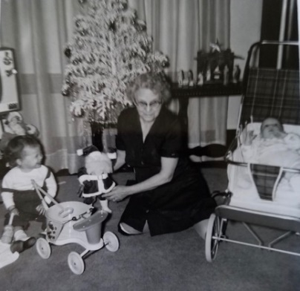 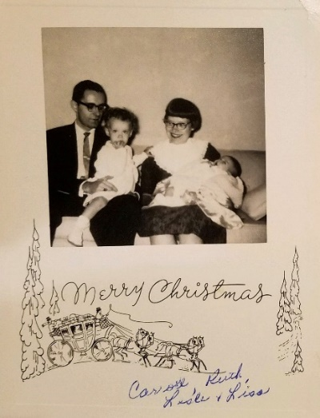 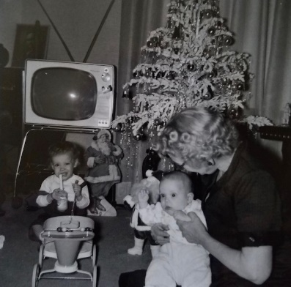

Christmas in Hutchinson, and then Oberlin.

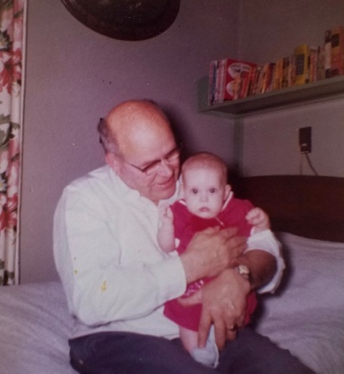 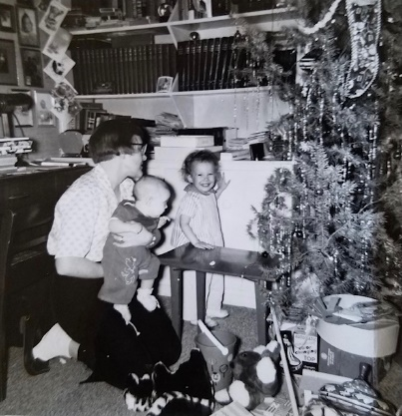 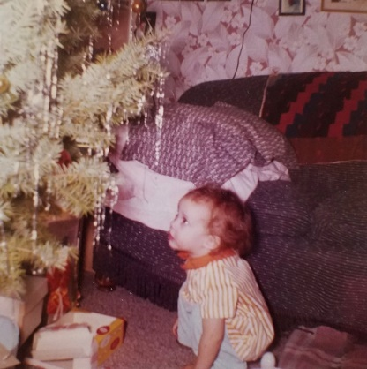

Merry Christmas from 1959!